React

1. Introduction: (https://reactjs.org/)
   1. A java script library for building user interfaces.
   2. In react we create user interfaces using components

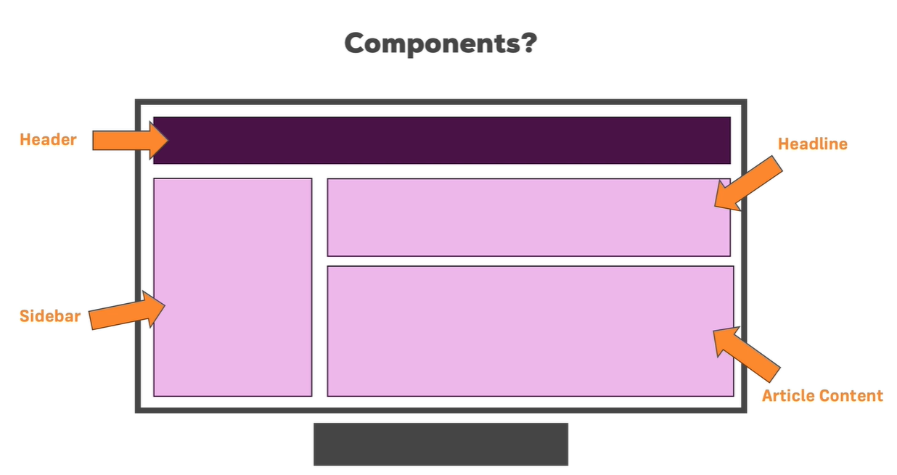

* 1. Why to use react

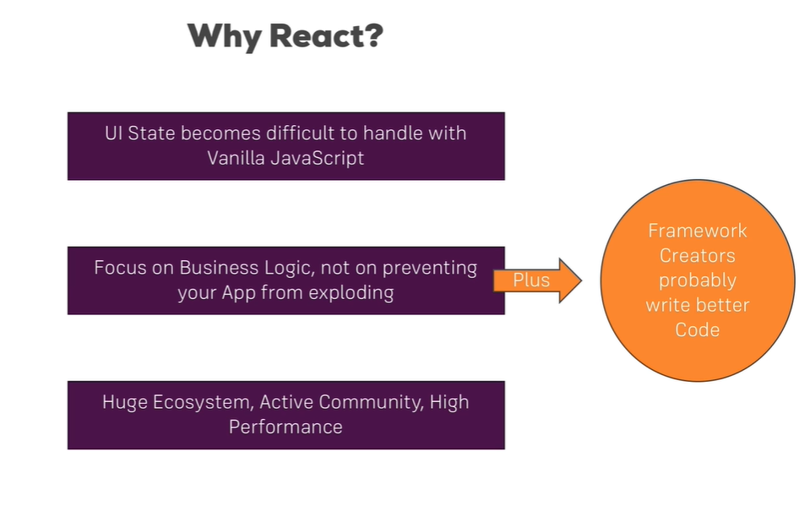

* 1. Single page vs Multi page applications

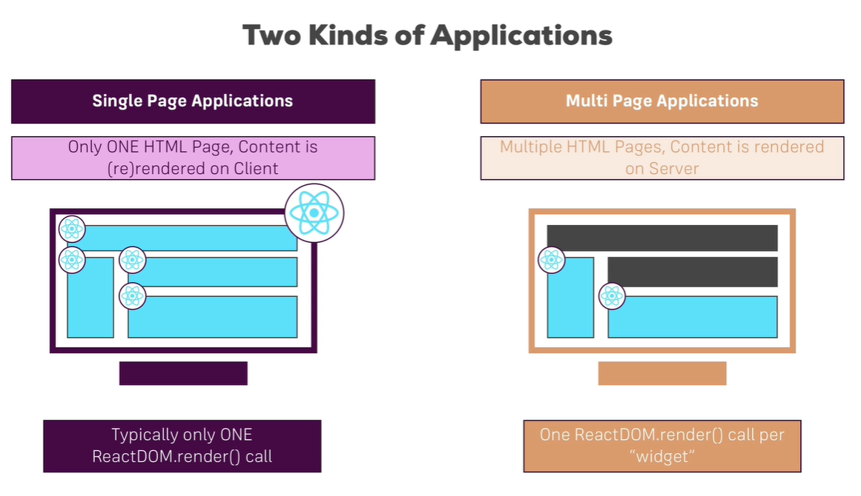

1. Next-Gen Java Script (ES6 or ECMAScript 6)
   1. ES6 is a next-gen of JavaScript, the ecma technical committee 39 governs ecma specification, they discovered new features to the javascript.
   2. ES6 can`t compile directly in browsers, so need an compiler from ES6 to ES5, for that compiling using babel, it produce the browser compatible javascript.
   3. ES5, which is the JavaScript version used in the “HTML5” world.
   4. Feature:
      1. let and const

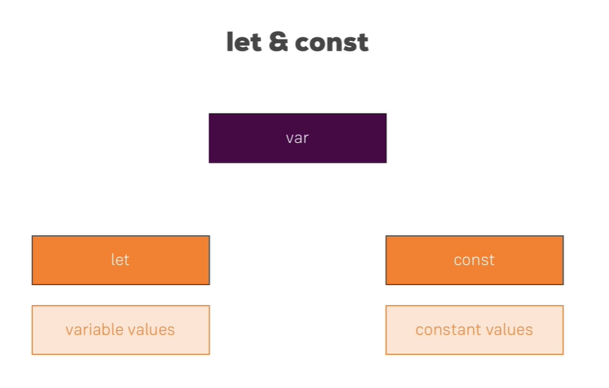

* + 1. Jsbin.com is online tool for writing java script code
    2. Arrow function

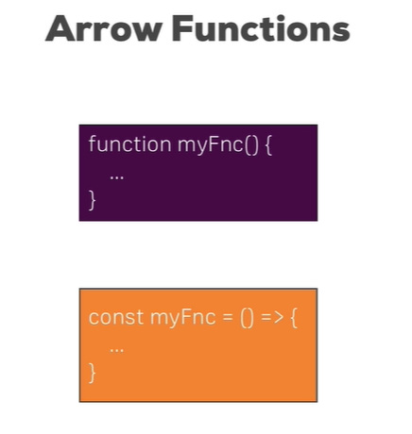

* + 1. Export and Import (Modules)

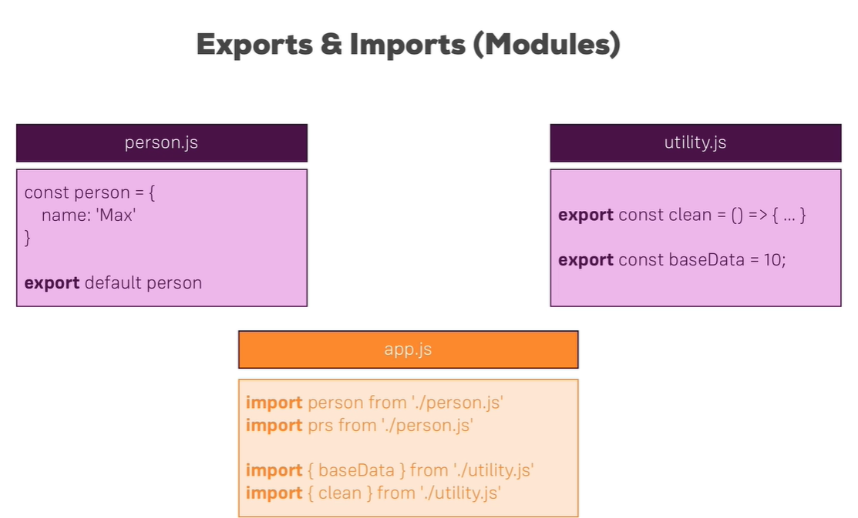

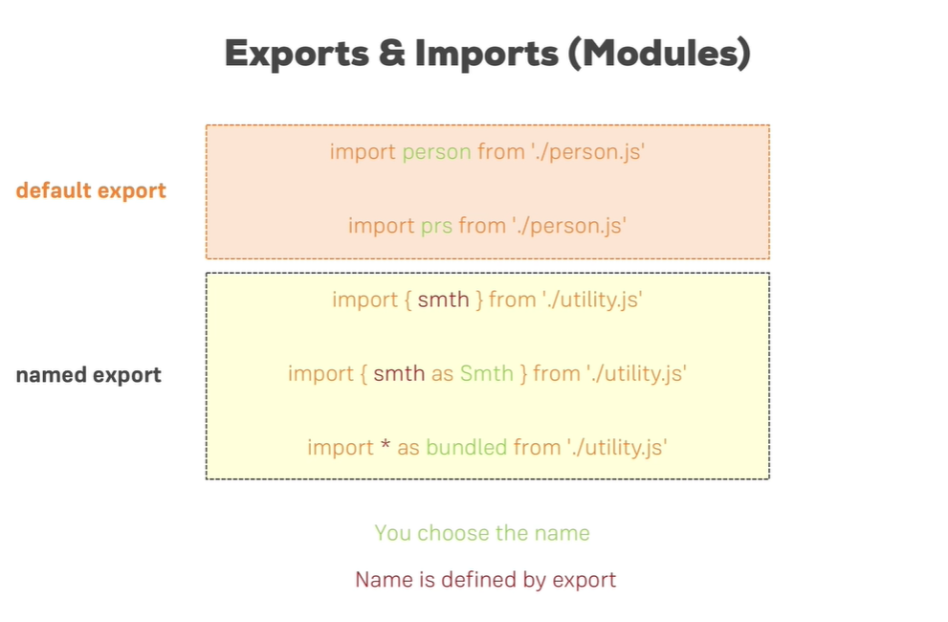

* + 1. Classes

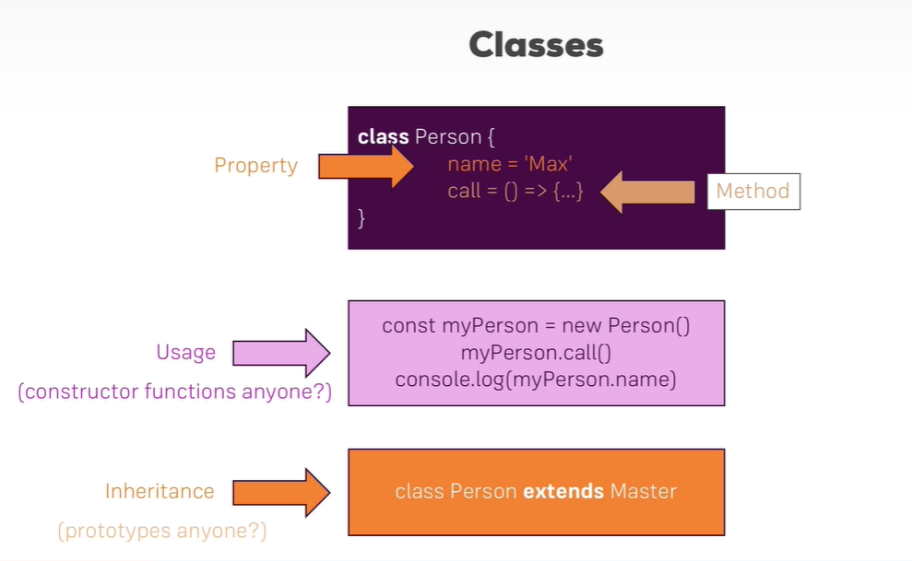

* + 1. Classes, Properties and Methods

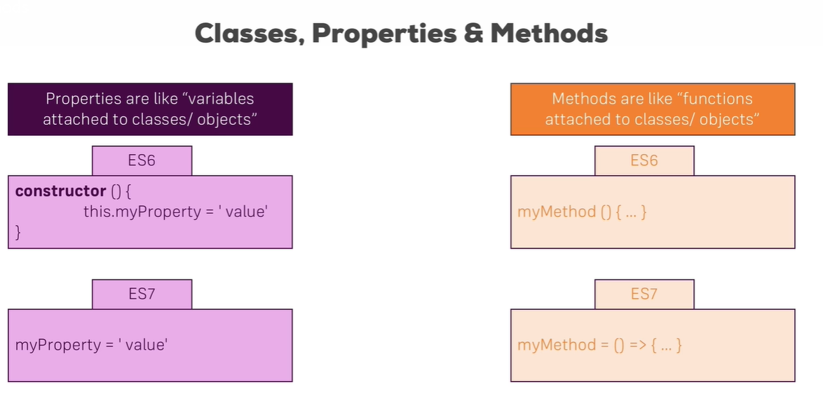

* + 1. Spread and Rest operators

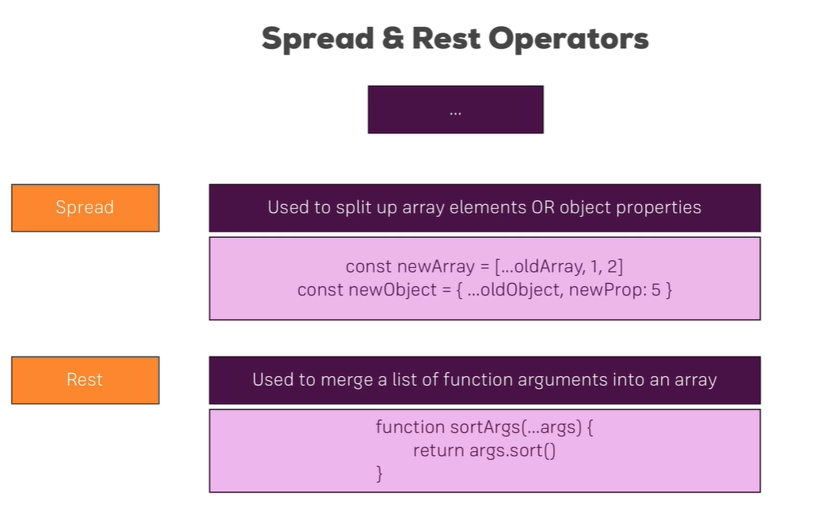

* + 1. Destructuring

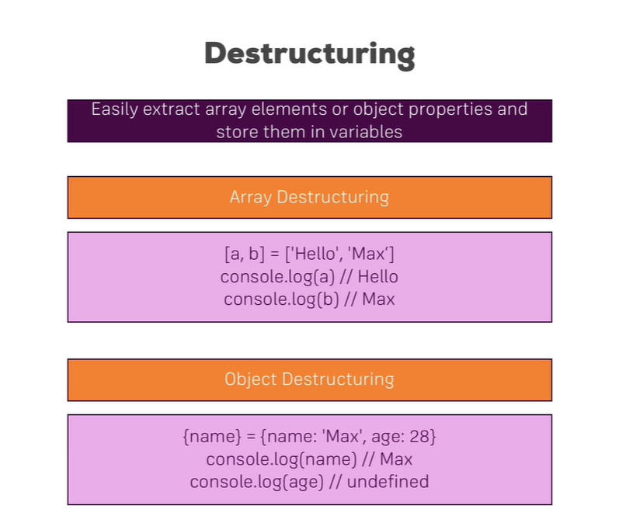

* + 1. Array Function which not part of next gen

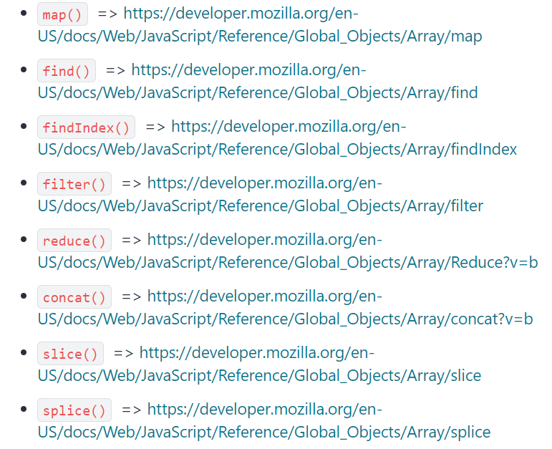

1. Base Features and Syntax
   1. Build workflow

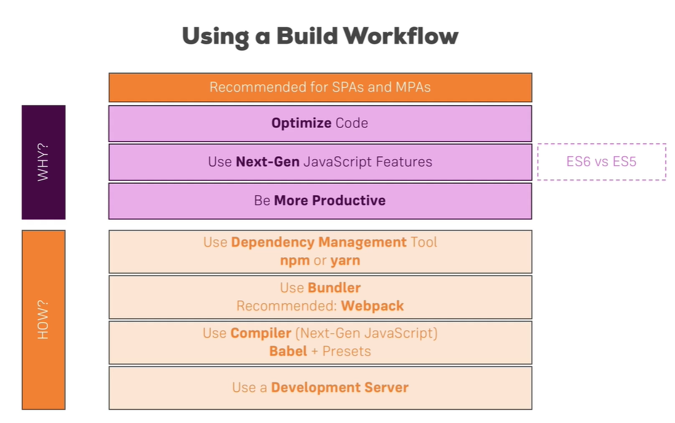

* 1. Create react app
     1. Command for creating react app: npx create-react-app app-name
     2. Dependencies:
        1. react v17 – for writing react code
        2. react-dom v17 – for rendering code in browser
        3. react-scripts v4 – for including next-gen javascript feature or ES6 feature and babel js
     3. run command: npm start
  2. JSX
     1. Code written with JSX will be converted to use **React.createElement().**
     2. JSX is just syntactic sugar for JavaScript, allowing you to write HTMLish code instead of nested React.createElement(...) calls.
     3. We always import React because it use createElement() in build.

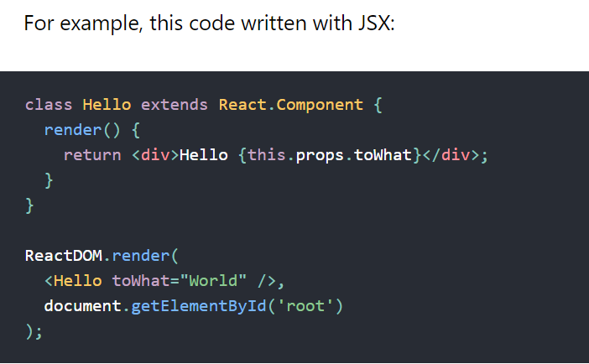

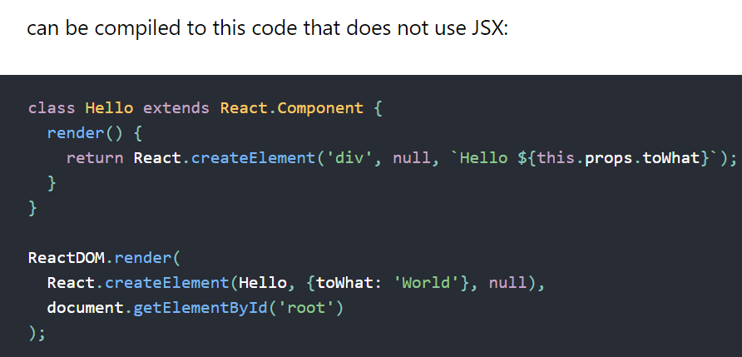

* 1. Functional Component

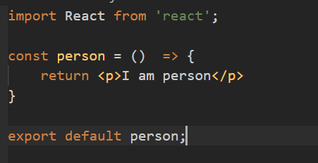

* 1. Working with props
     1. **props** allow you to pass data from a parent (wrapping) component to a child (embedded) component.
     2. Whilst props allow you to pass data down the component tree (and hence trigger an UI update)

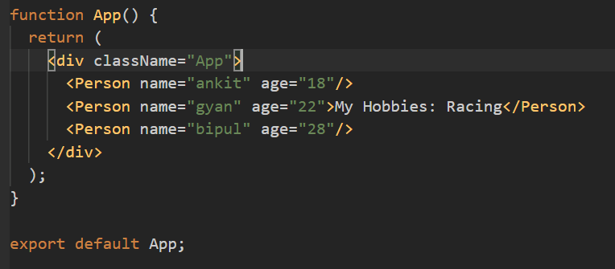

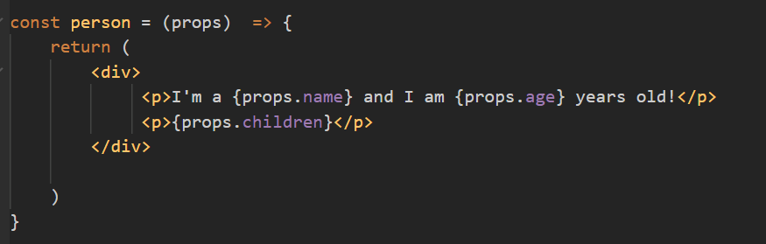

* 1. Working with state in Class Component
     1. **state** is used to change the component, well, state from within. Changes to state also trigger an UI update.

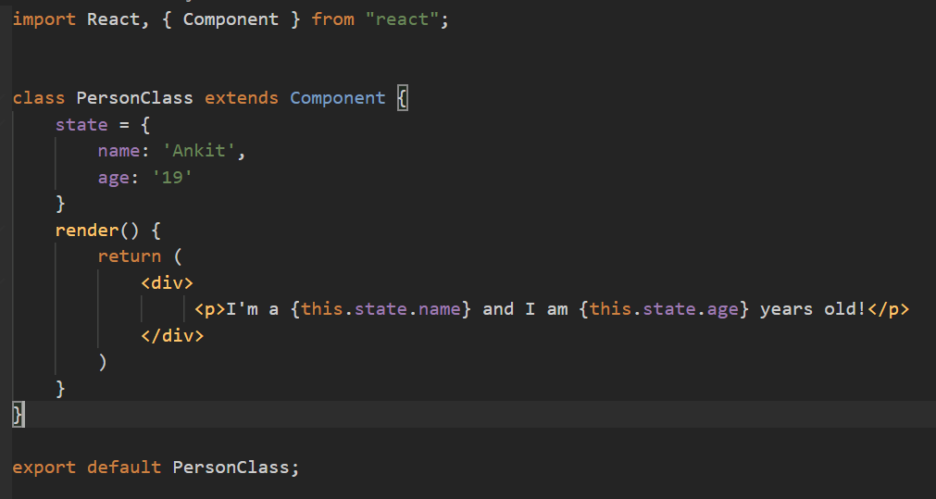

* 1. Props & State
     1. props and state are CORE concepts of React.
     2. Actually, only changes in props and/ or state trigger React to re-render your components and potentially update the DOM in the browser.
  2. Handling events with methods

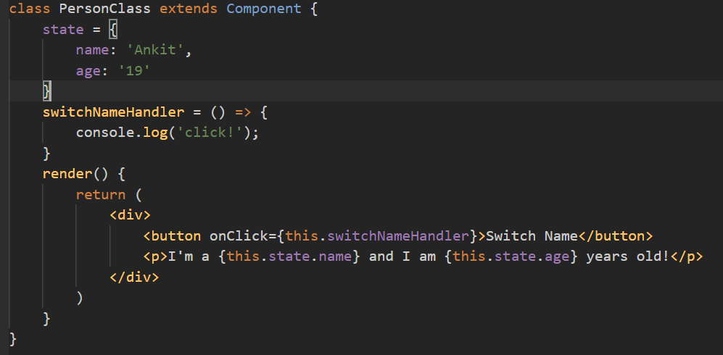

* 1. Manipulating the State inside method
     1. Whenever we change state we should use setState function which will available when we extends Component. Because it will re-render the component in browser as state changes.
     2. If we use this.state to change state value then it will not re-render in browser.

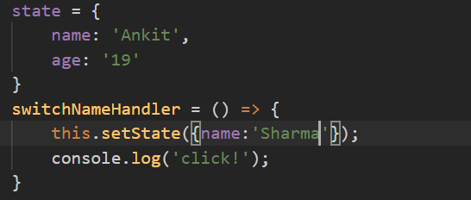

* 1. State in functional component
     1. In functional component we use useState hook to manage state in functional component.

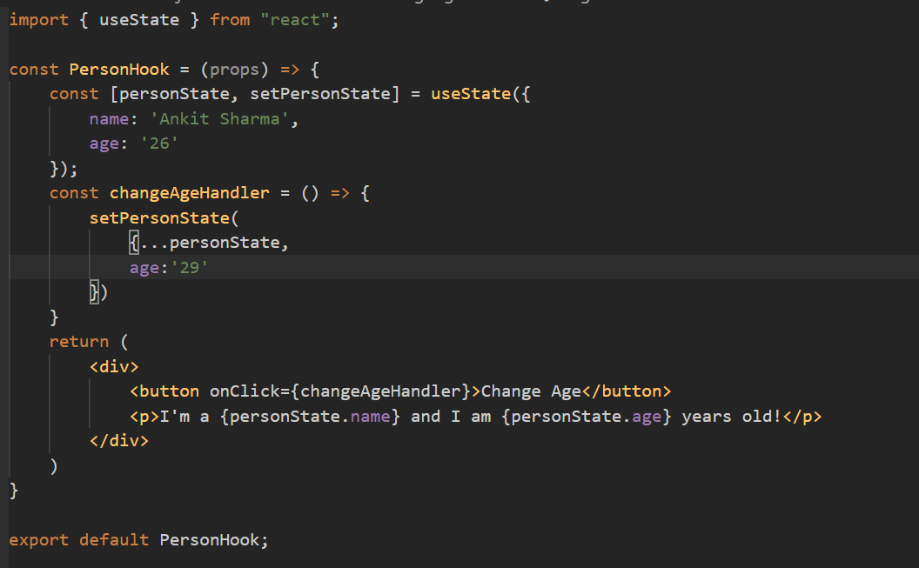

* 1. Passing Method References Between Components

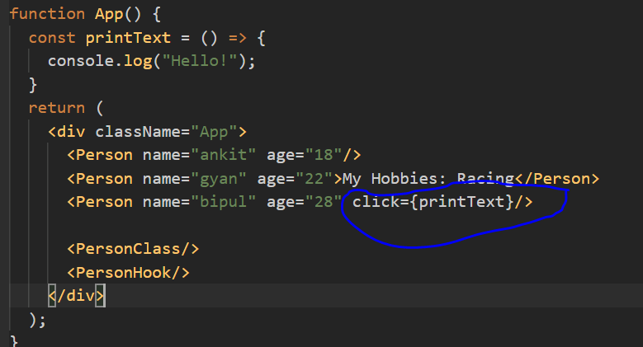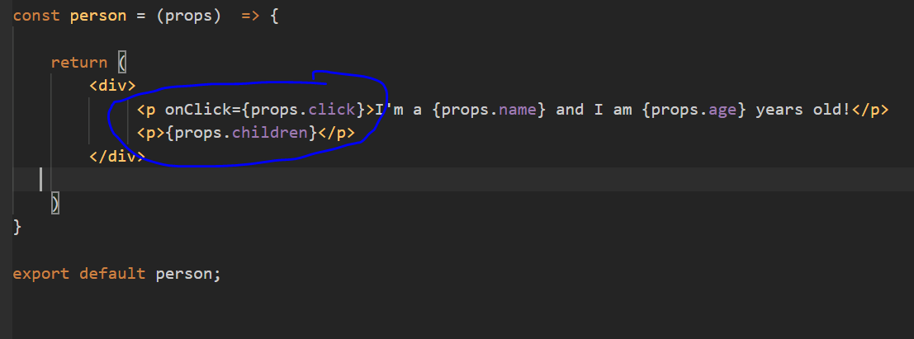

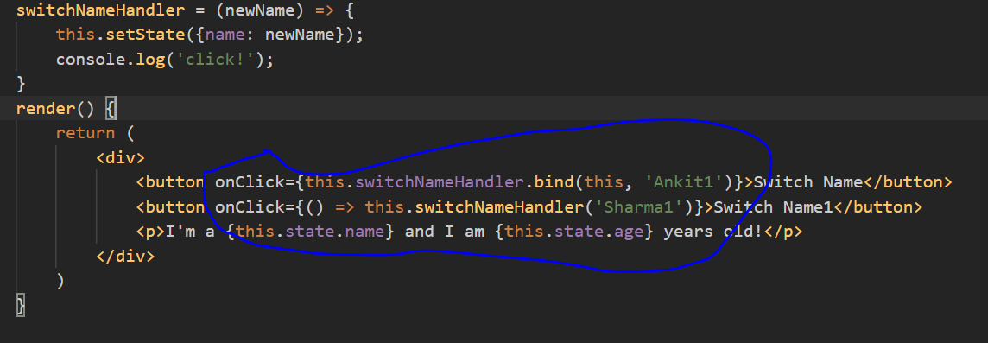

* 1. Adding Two Way Binding

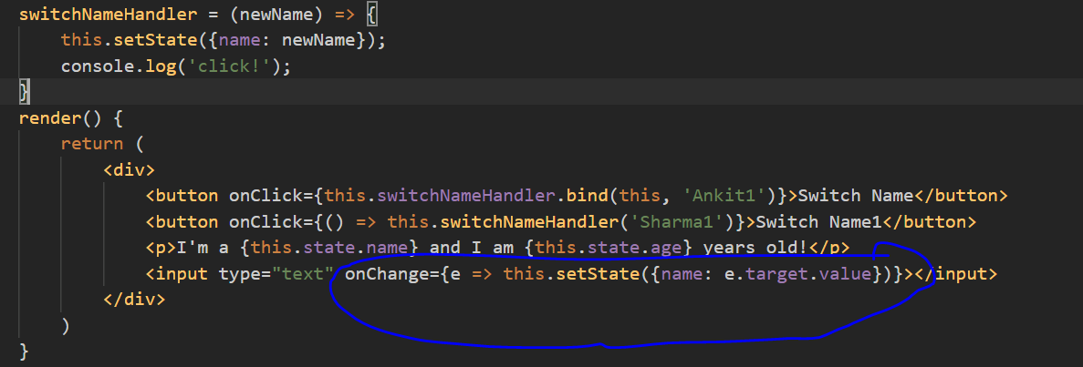

* 1. Adding Styling with Stylesheets

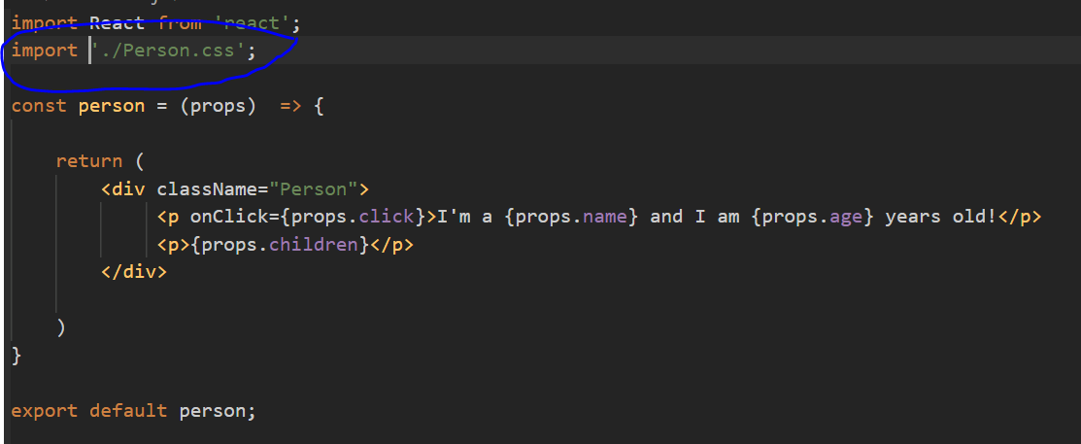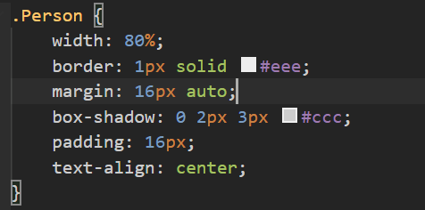

* 1. Inline style

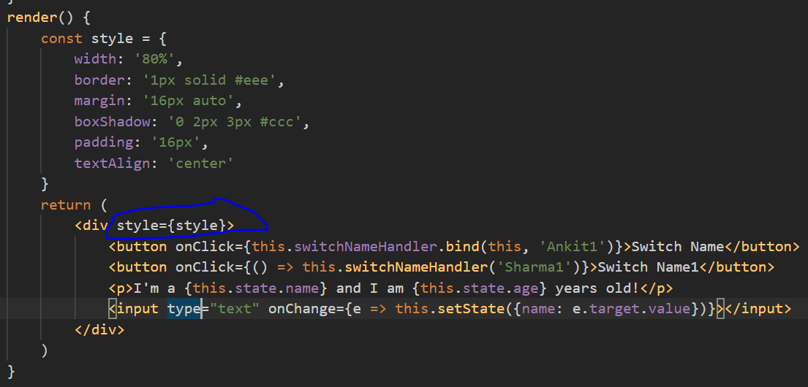

1. Lists and Conditions
   1. Render content conditionally
      1. In JSX we can use ternary operator(?) to show and hide some element.
      2. If else don’t work inside JSX code.

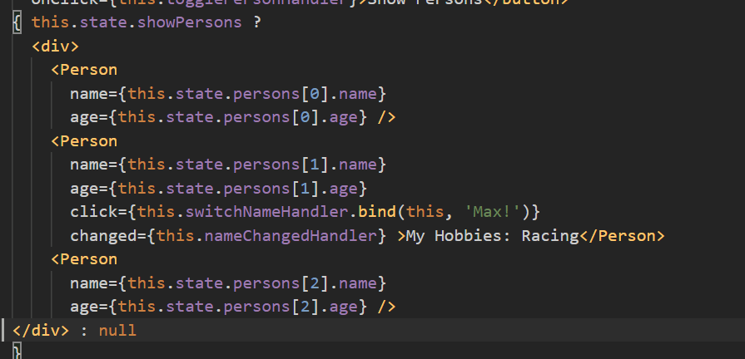

* 1. Handling Dynamic Content "The JavaScript Way"

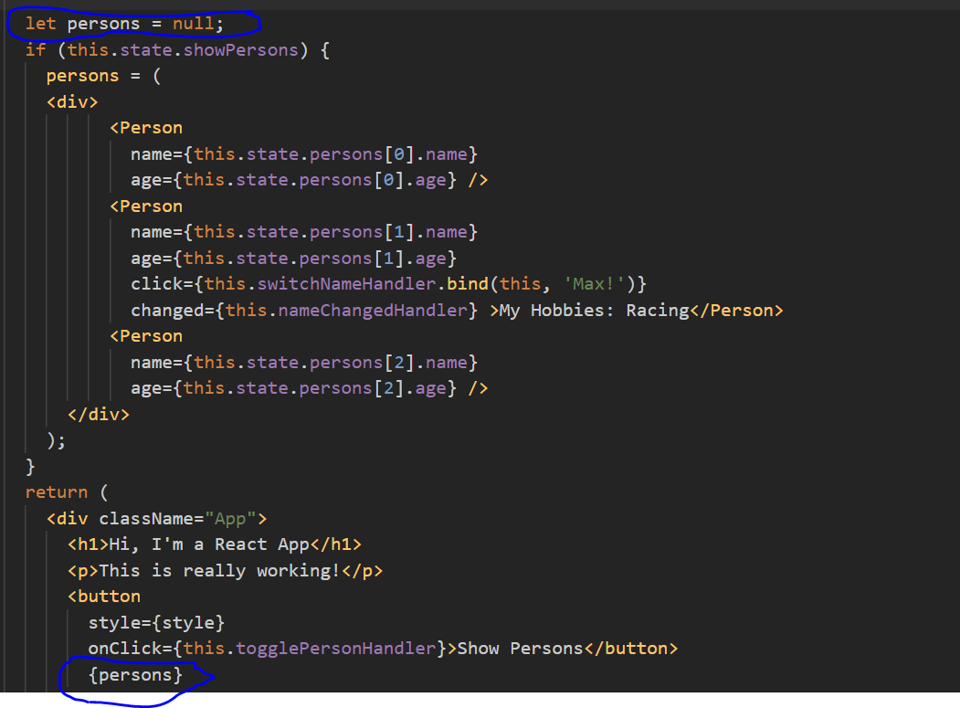

* 1. Outputting Lists

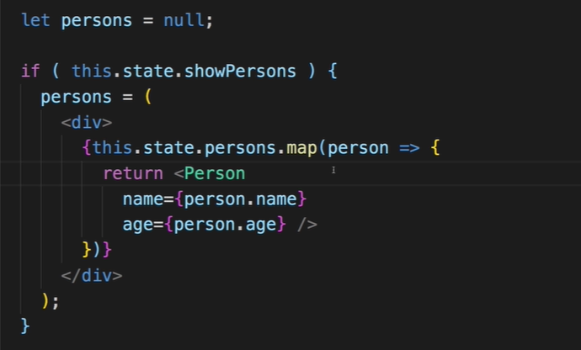

* 1. Updating state Immutably

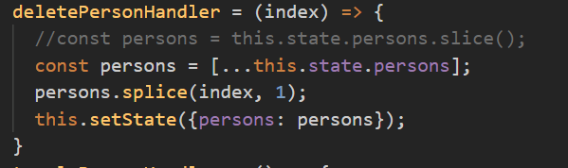

* 1. Keys in Listing

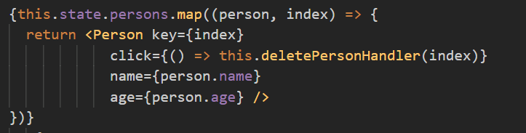

1. Styling React Components & Elements
   1. If we create const and assign it for inline styling we can’t use pseudo classes in react.
   2. Change style in java script

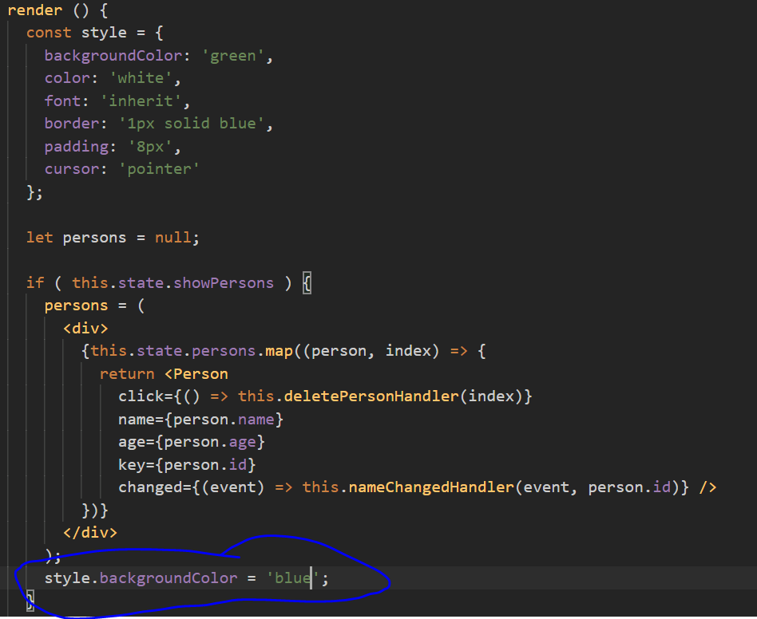

* 1. Setting Class Names Dynamically

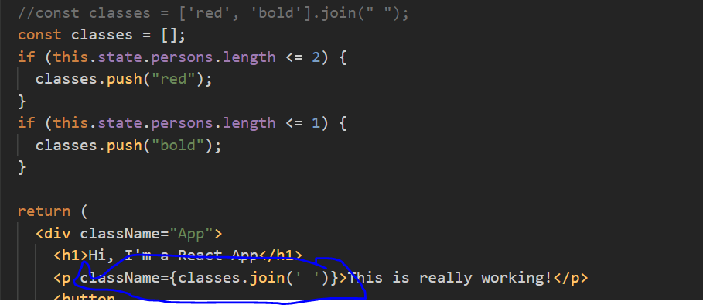

* 1. Adding and Using Radium
     1. Command: npm install –save radium
     2. Radium is a set of tools to manage inline styles on React elements. It gives you powerful styling capabilities without CSS.
     3. It will allow to use pseudo classes in jsx.
     4. Also allow to use media query. While using media query or keyframes we have to wrap app div in StyleRoot tag.
     5. It will work as inline style in backend

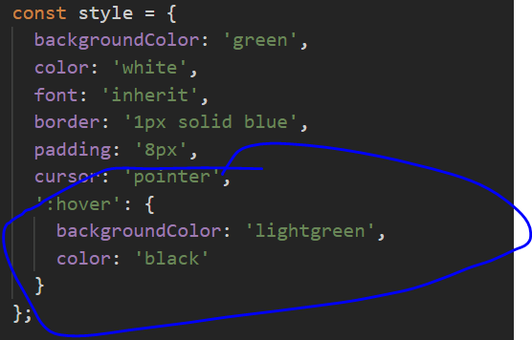

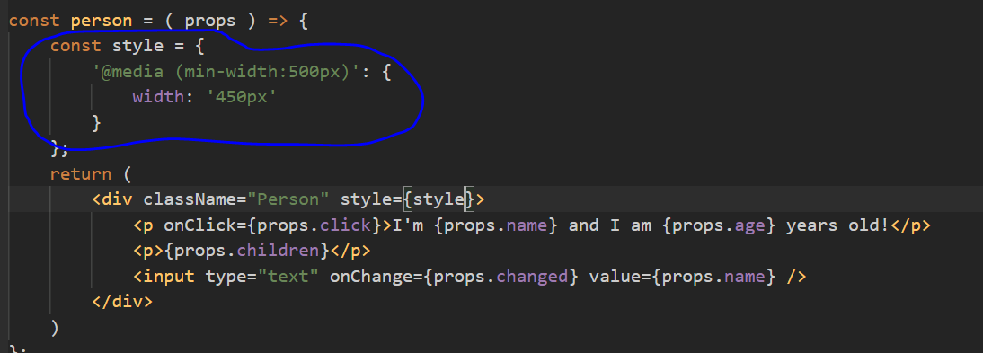

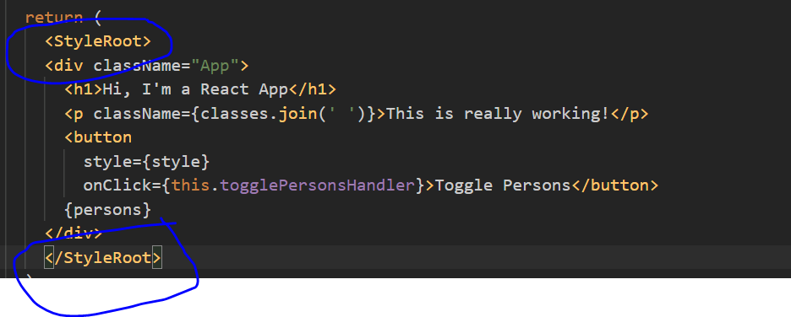

* 1. Styled Components
     1. Use the best bits of ES6 and CSS to style your apps
     2. Command: npm install --save styled-components
     3. It will work as normal css, put css in inside style tag use dynamic class in element tag.

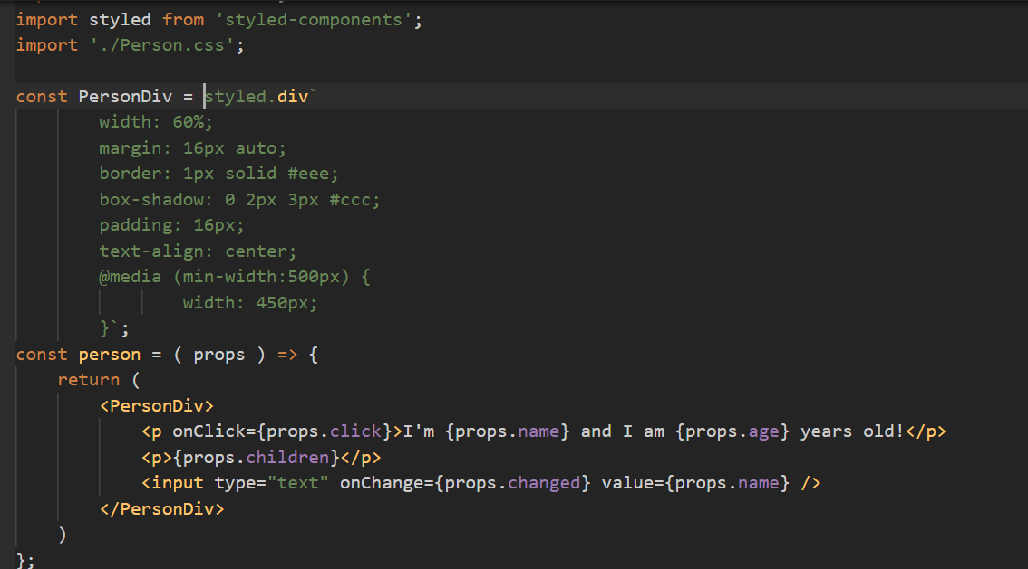

* + 1. We can pass props and use inside styling code.

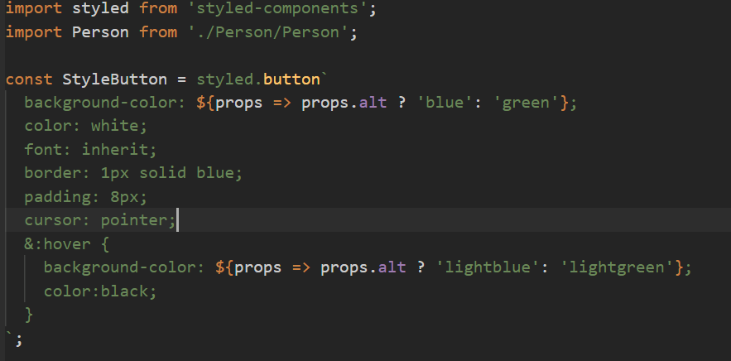

* 1. CSS Modules
     1. With CSS modules, you can write normal CSS code and make sure, that it only applies to a given component.
     2. it'll simply automatically generate unique CSS class names for you. And by importing a JS object and assigning classes from there, you use these dynamically generated, unique names.
     3. By the way, if you somehow also want to define a global CSS class in such a .css file, you can prefix the selector with **:global** .
     4. this feature is available with react-scripts@2.0.0 and higher. And before to that we have to config by own in webpack files.

1. Debugging React Apps
   1. Install **React Developer Tools** extension in browser
   2. Using Error Boundaries (React 16+)
      1. It’s a higher order component which wrap a component to handle all error that component may throw.
      2. Only use error boundaries when you know some thing might fail and you can’t control it. Also error boundaries only work in production not in development mode.
      3. If it’s a normal error then you can fix it and won’t use error boundaries.

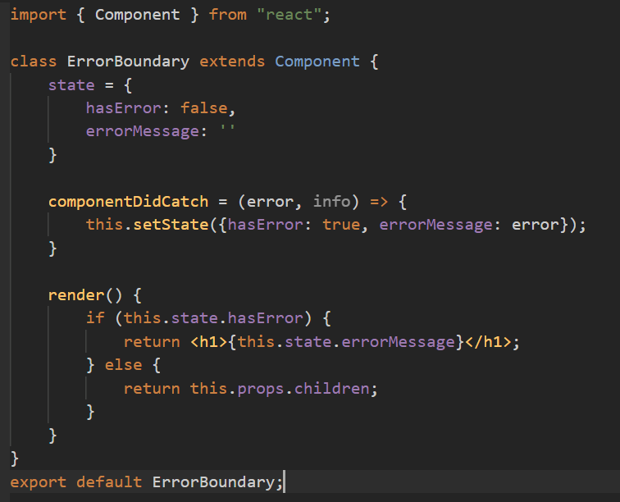

1. Components & React Internals
   1. Class vs Functional Component

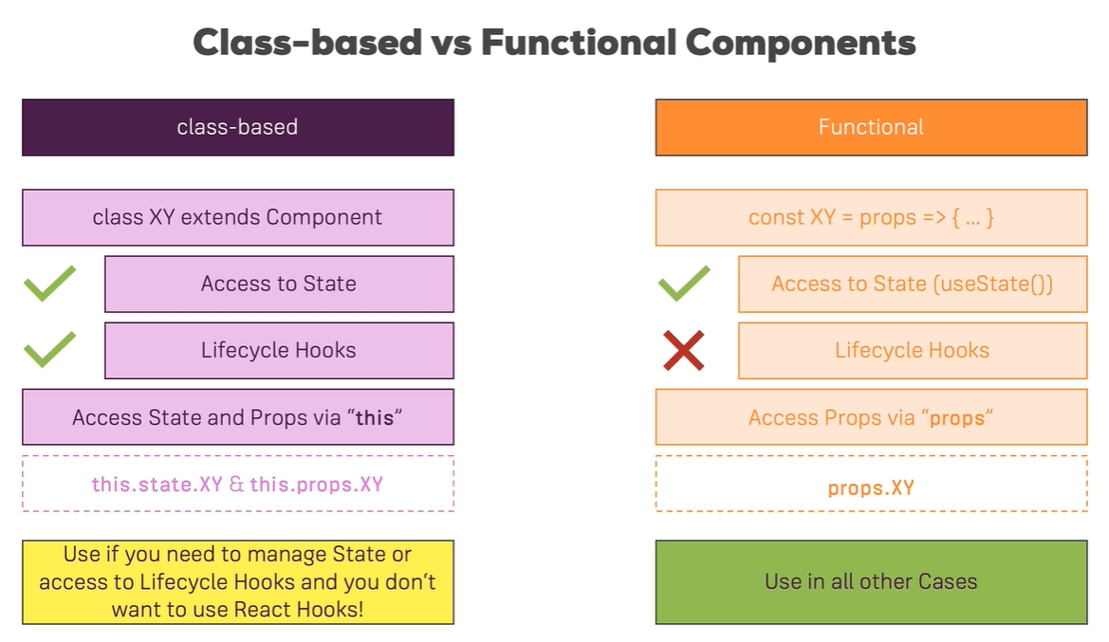

* 1. Class Lifecycle methods
     1. Creation phase

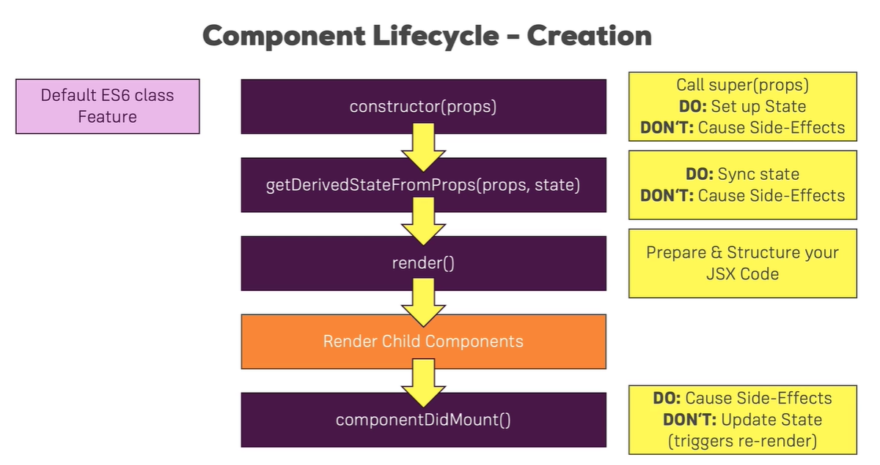

* + 1. Updating Phase

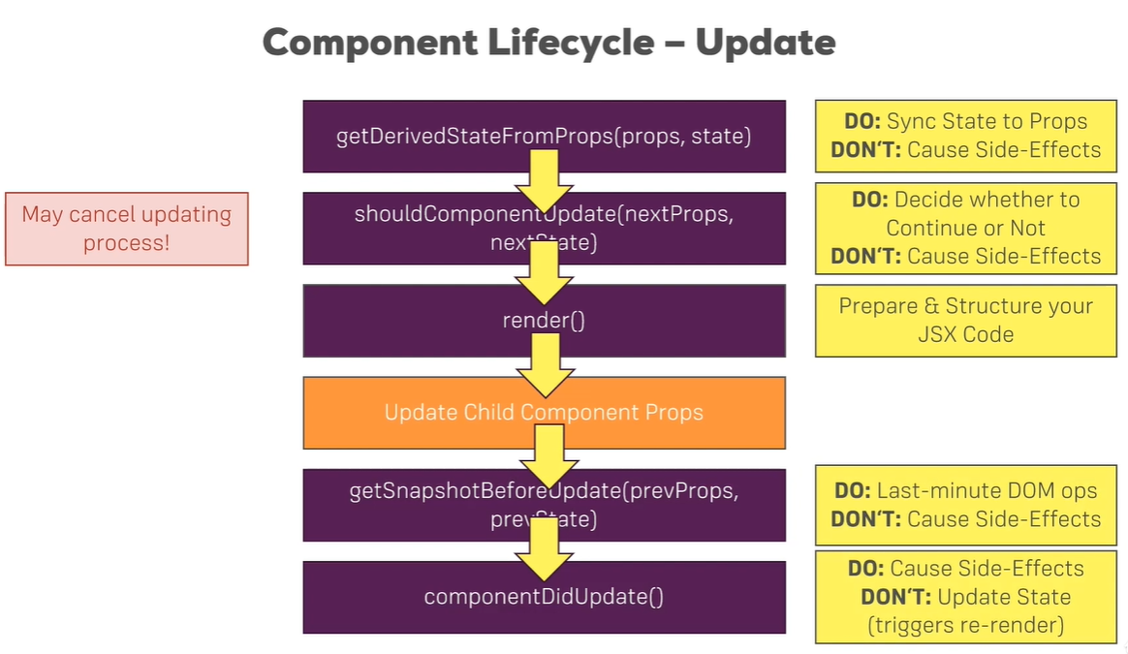

* + 1. Catch Error: - We have function called **componentDidCatch**()
  1. **useEffect()** in functional component
     1. it run for every DOM update

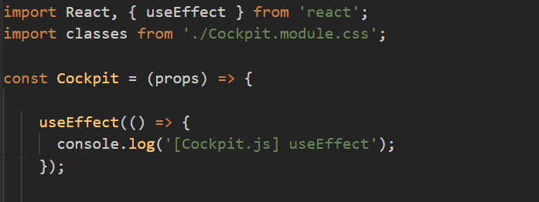

* + 1. Controlling the useEffect() Behavior
       1. Run only once
       2. Run when some props or state changes

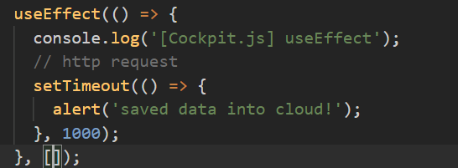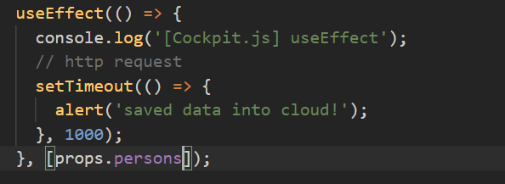

* + 1. Cleaning up with Lifecycle hooks and useEffect()

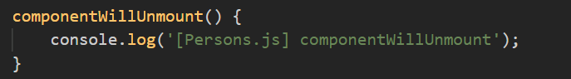

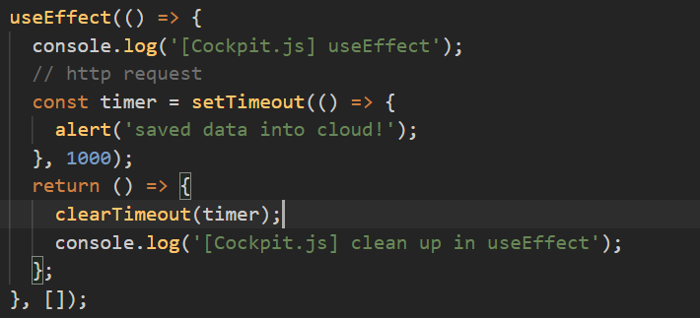

* 1. Optimization
     1. Using shouldComponentUpdate for Optimization

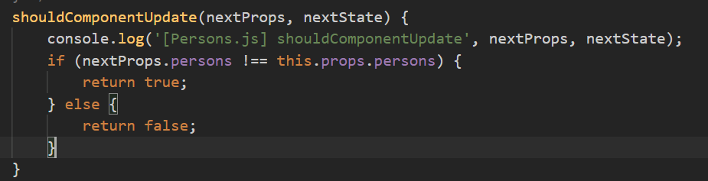

* + 1. Optimizing Functional Components with React.memo()

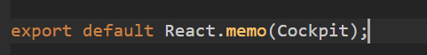

* + 1. PureComponents instead of shouldComponentUpdate
       1. It check all props data and then render so if we use shouldComponentUpdate then we have to add all check condition and then pass true in return.

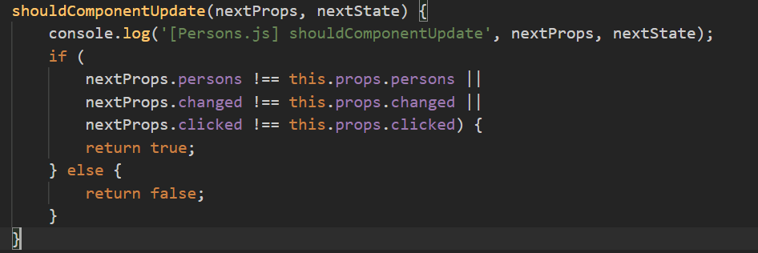



* 1. How React Updates the DOM

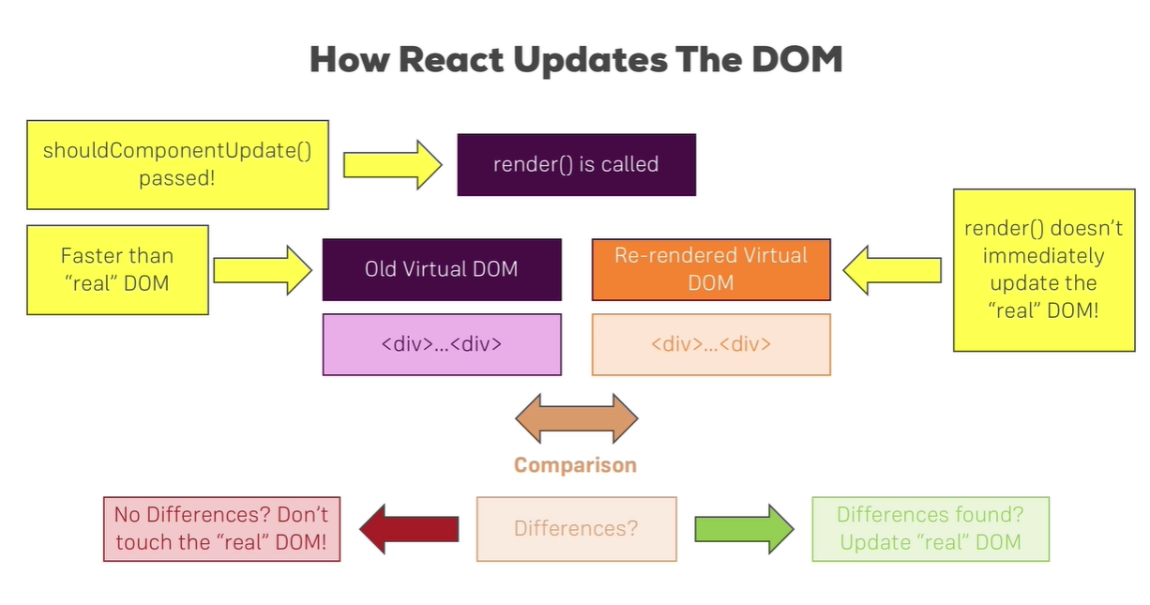

* 1. Rendering Adjacent JSX Elements

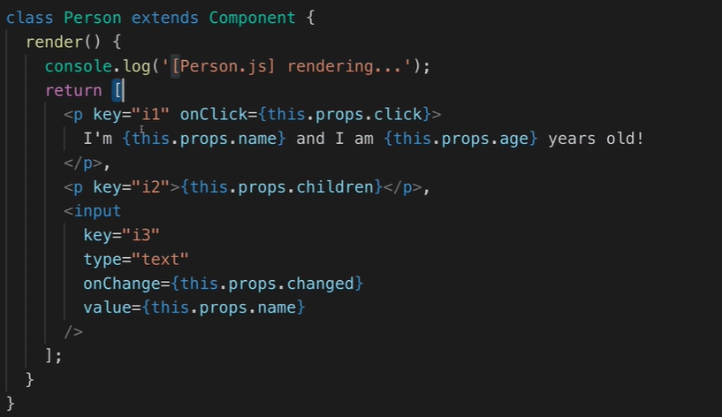

* + 1. Create Aux component(HOC) just to wrap all jsx

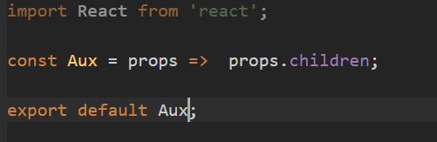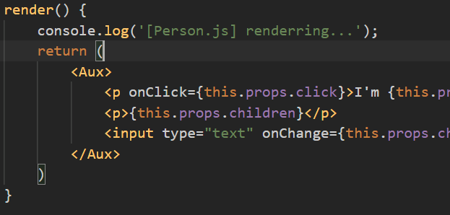

* + 1. Using React.Fragment

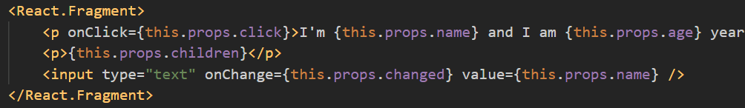

* 1. Higher Order Components (HOC)
     1. Hoc just wrap other component and provide extra logic to that component.

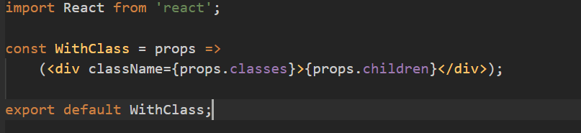

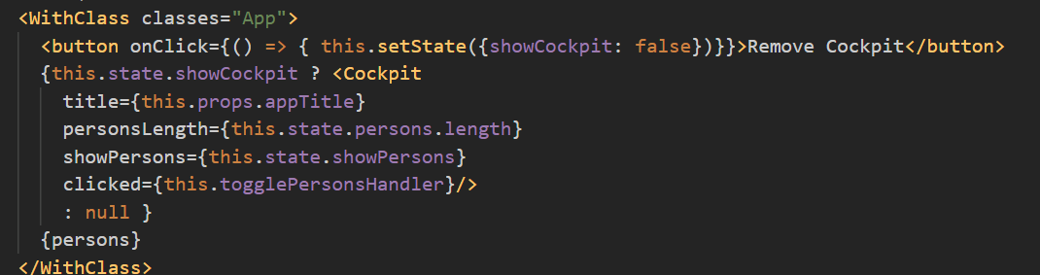

* 1. Another Form of HOCs

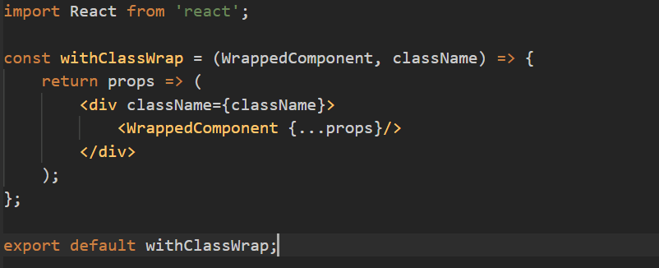



* 1. Setting State Correctly

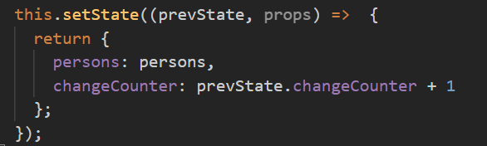

* 1. Using PropTypes
     1. npm install –save prop-types
     2. it work in both functional and class component
     3. this we use when we want to restrict the props user pass for component
     4. this mostly use when we create react library

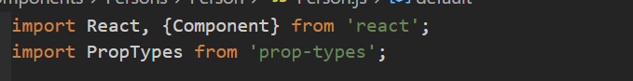

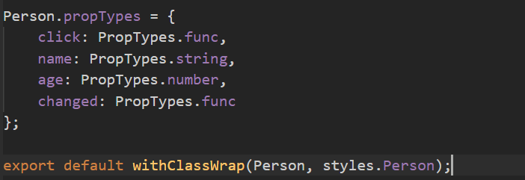

* 1. Using Refs
     1. Two ways we can use Refs.

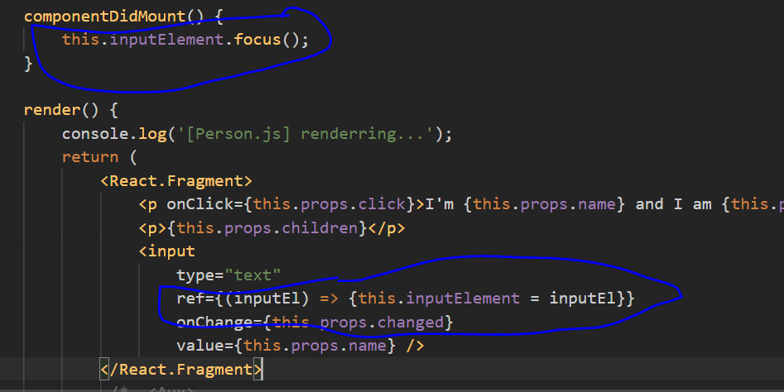

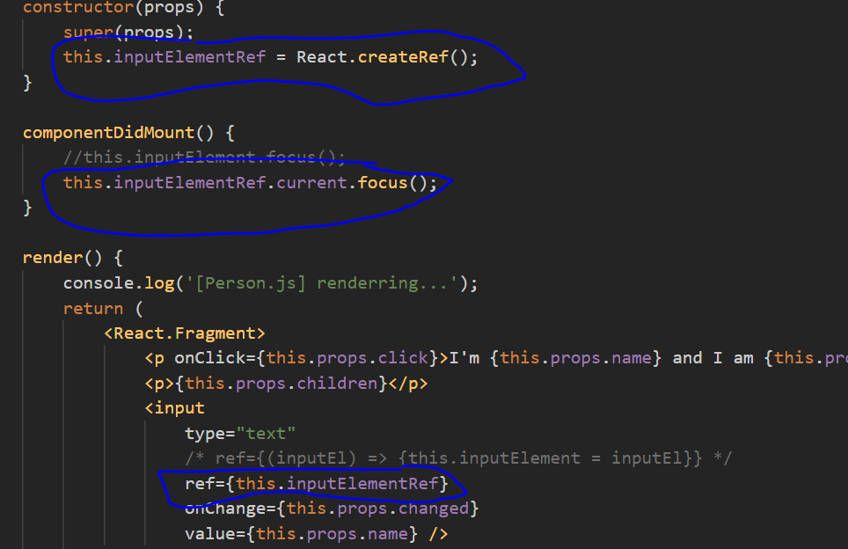

* 1. Refs with React Hooks
     1. In functional component we have useRef() hook to create refs.

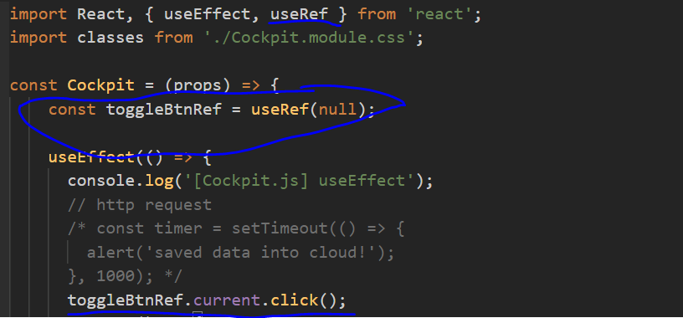

* 1. Using the Context API
     1. Using context we can pass data between component without passing through props.
     2. Change in context will not re-render the DOM.
     3. Using context we can share data and function between components.
     4. In context Api, we have Provider and Consumer.

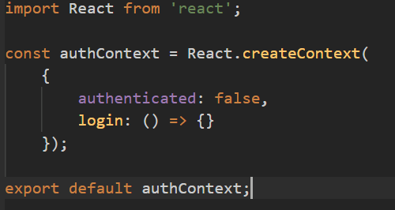

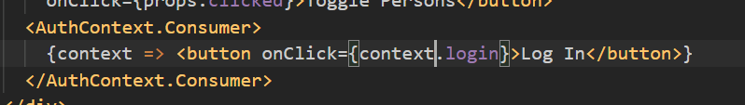

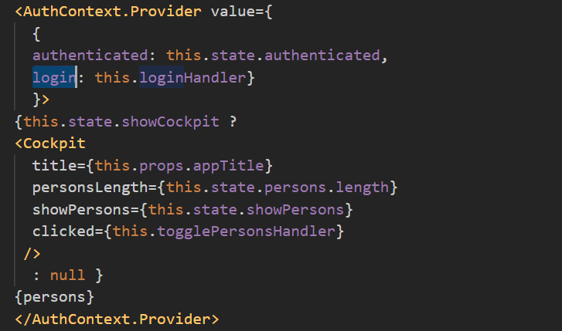



* 1. contextType
     1. to access context in js code with we need to declare contextType.
     2. contextType we can use in only class based component.

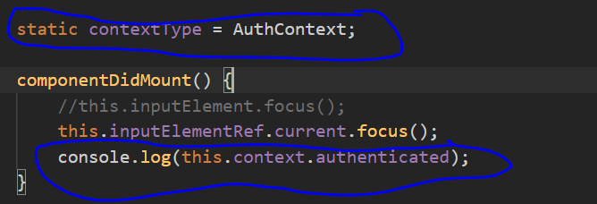

* 1. useContext()
     1. in functional component we can access context in js code by useContext() hooks.

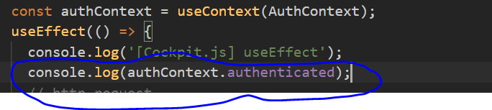

1. Http & Ajax
   1. get request using axios (this we should call in componentDidMount because we need to call this only once)

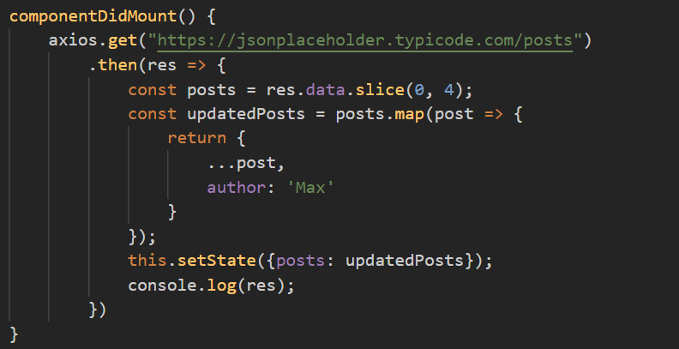

* 1. get single data using axios (this we should call in componentDidUpdate as we get id from props and when id changes again we need to send http request but to handle infinity loop we need to add some condition so it won’t break )

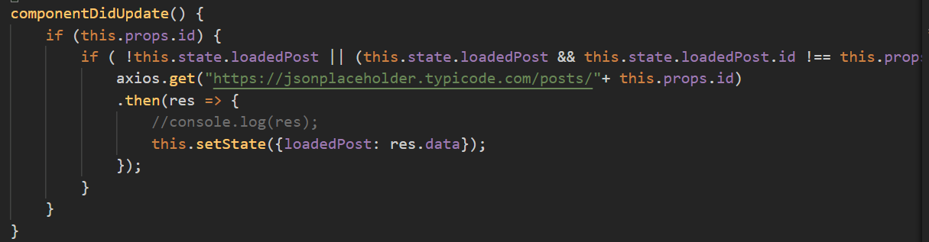

* 1. post request using axios

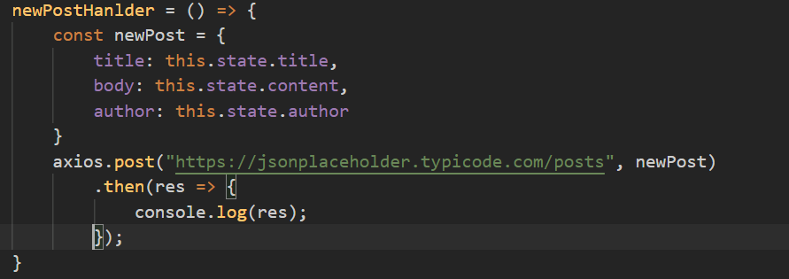

* 1. delete request using axios

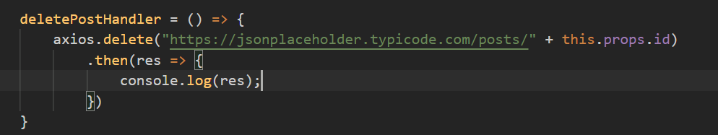

* 1. error handle for http request using axios

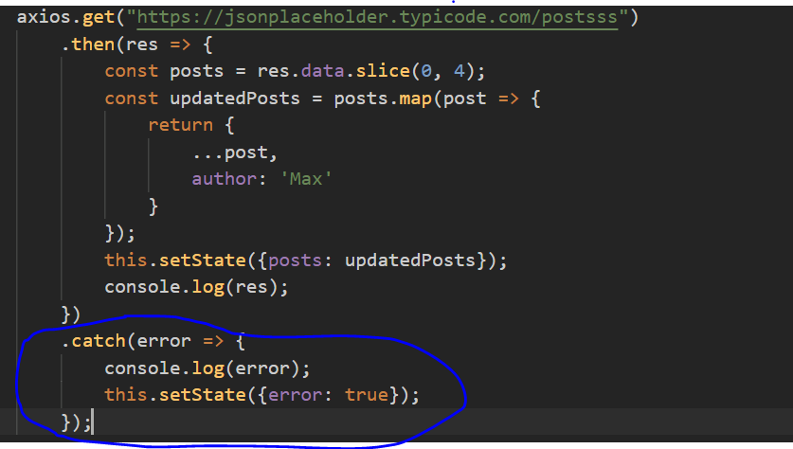

* 1. Adding Interceptors to Execute Code Globally
     1. Using Interceptors we can handle error globally
     2. And also modify the request before sending and the response after receiving
     3. Add interceptors in index.js file as its global place for code.

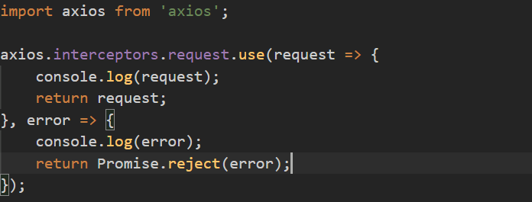

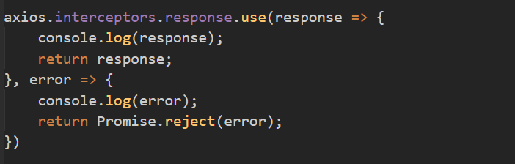

* 1. Remove interceptor

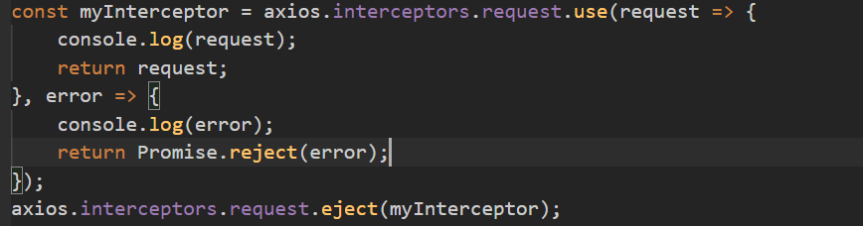

* 1. Setting a Default Global Configuration for axios

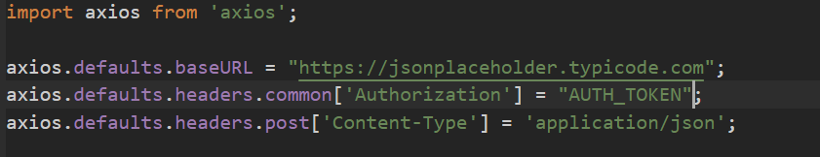

* 1. Creating and Using Axios Instances

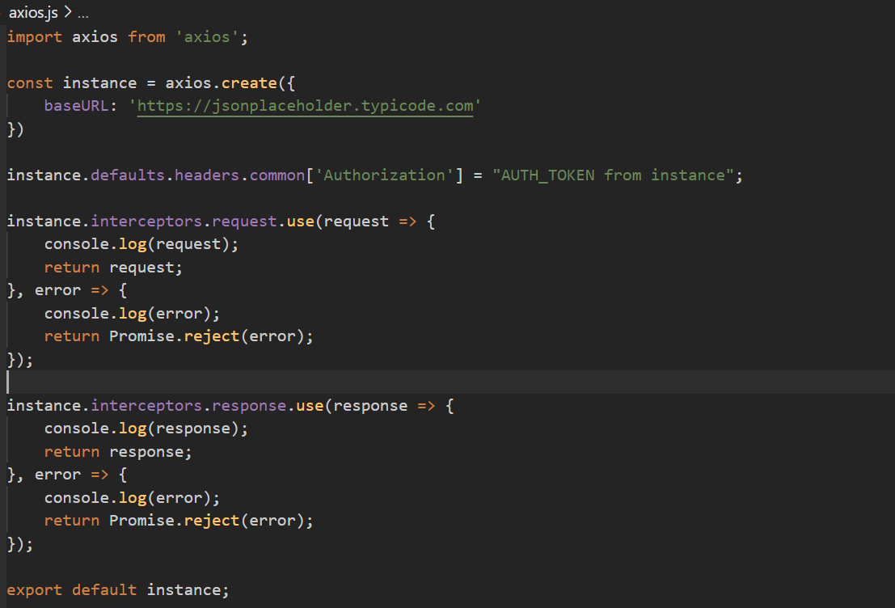

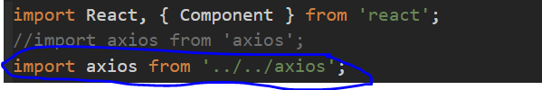

1. Routing
   1. Introduction router package

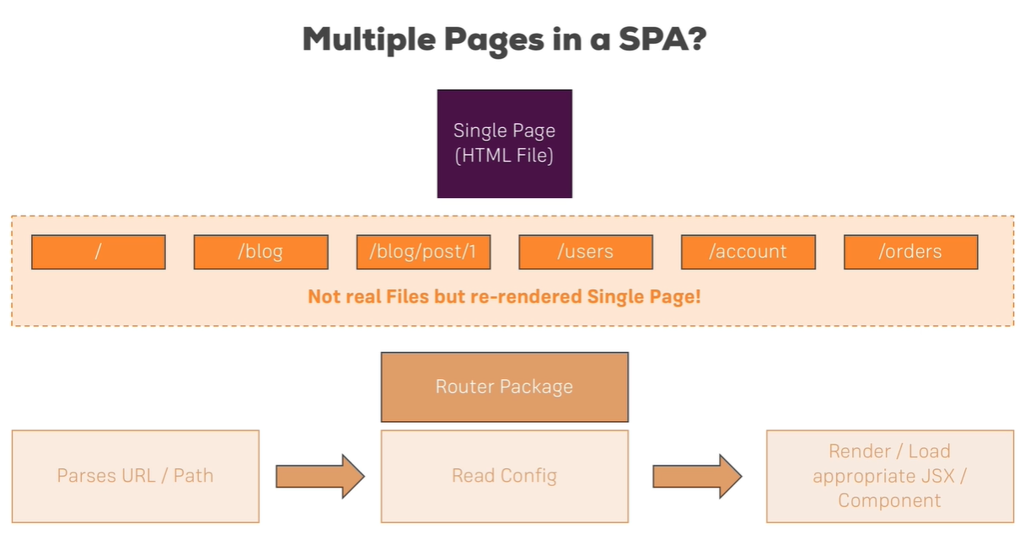

* 1. Command : npm install –save **react-router-dom**
  2. Setting Up the Router Package

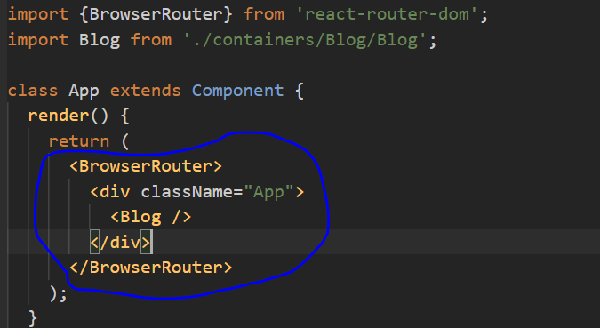

* 1. Setting Up and Rendering Routes
     1. Render jsx code based on path
     2. Use exact to full path check and render attr for providing jsx code.

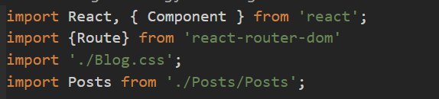

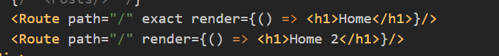

* 1. Rendering Components for Routes



* 1. Switching Between Pages
     1. Here it always reload page and send new request

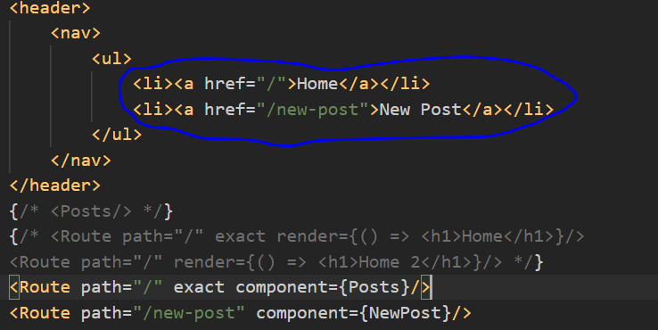

* 1. Using Links to Switch Pages
     1. Import { Link } from ‘react-router-dom’
     2. Here it won’t reload page and not send new request

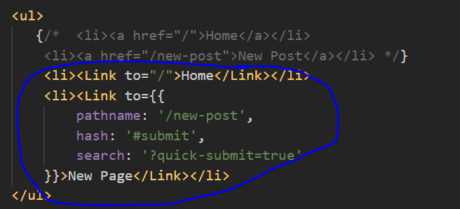

* 1. Using Routing-Related Props
     1. In props we get routing related information and function as well.

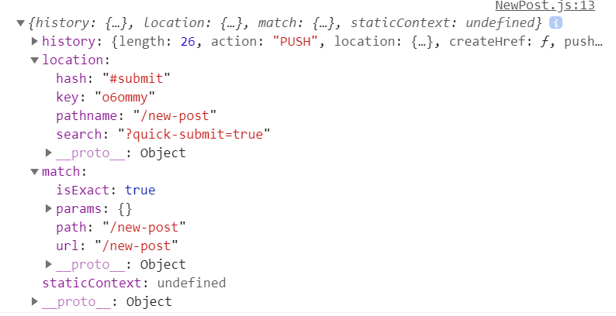

* 1. The "withRouter" HOC & Route Props
     1. It only pass props to parent component not all child component so if we need router props at child component then we need to manually pass props to child component.
     2. There two way to pass
        1. We can router props from parent to child as normal props

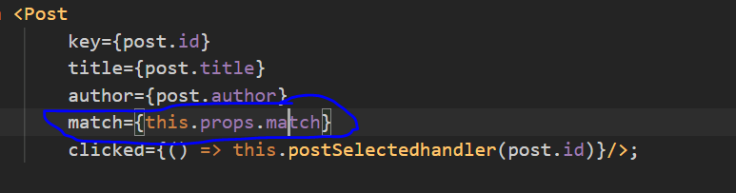

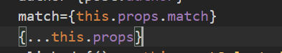

* + - 1. Another way is to use withRouter hoc

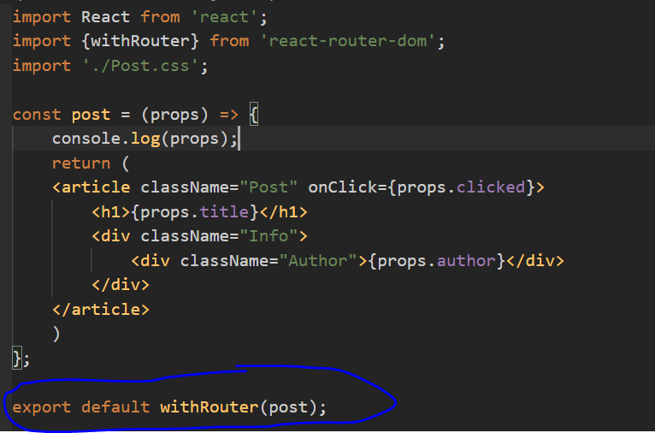

* 1. Absolute vs Relative Paths
     1. Link “to” attr is always absolute path(means add path with domain).
     2. So when we are at parent component and again add a path in current path then

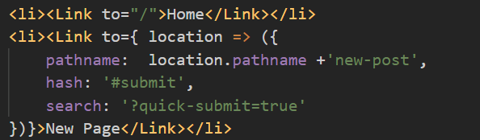

* 1. Styling the Active Route
     1. **Link** don’t provide any class so for styling we should use **NavLink** which will add class active to <a> tag.

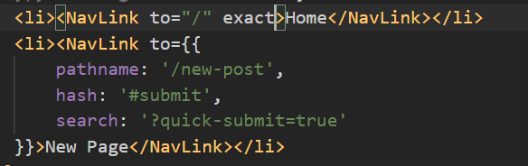

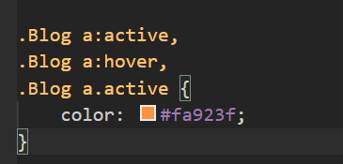

* + 1. We can override class active to different classname using **activeClassName** attr and add new style using **activeStyle** attr.

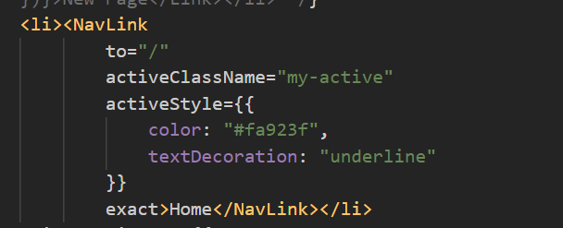

* 1. Passing Route Parameters

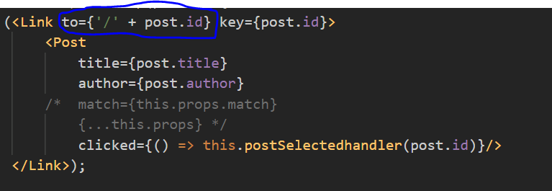

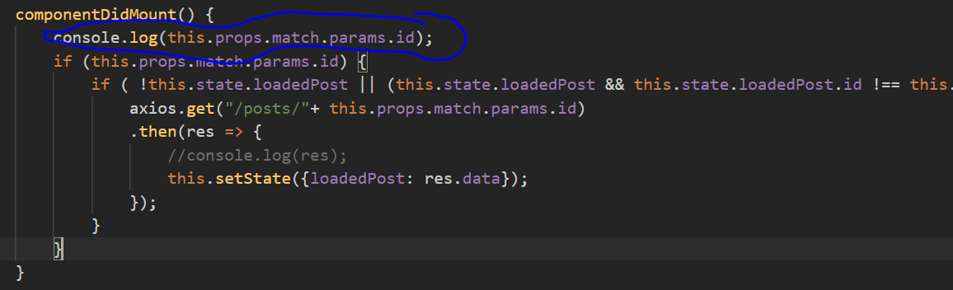

* 1. Parsing Query Parameters & the Fragment

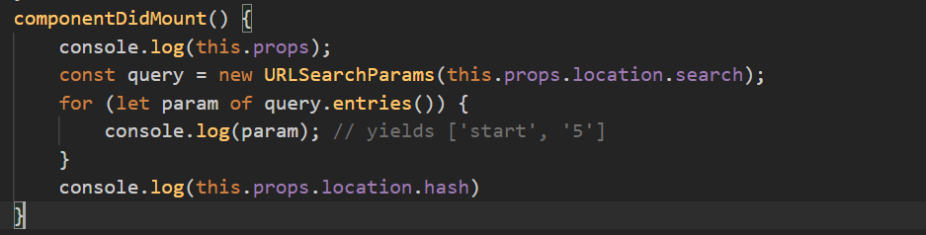

* 1. Using Switch to Load a Single Route
     1. It render only one route then stop search for other route.
     2. And without switch it render all route which match the path.
     3. Order should be correct otherwise it create issue.
     4. We should use switch when it render multiple route.

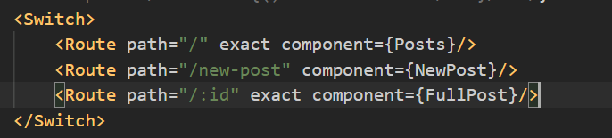

* + 1. We can combine way to add route

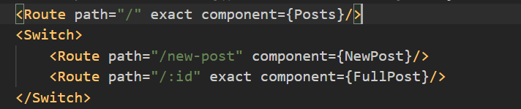

* 1. Navigating Programmatically
     1. We can use router history props and call push() function to navigate.

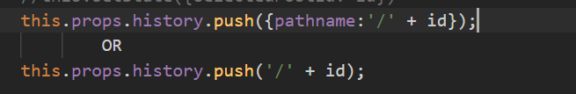

* 1. Understanding Nested Routes (route at child component)

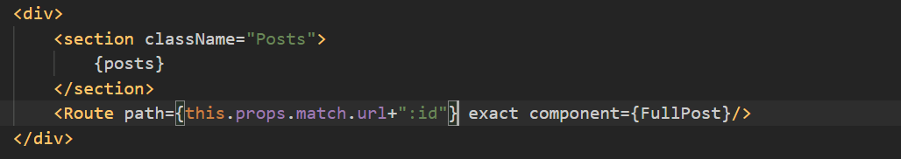

* 1. Redirecting Requests
     1. React-router-dom provide Redirect tag which allow t o redirect request from one path to other page.

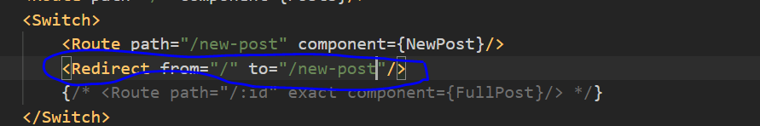

* 1. Conditional Redirects
     1. We can only use to attr as well in Redirect.
     2. It will replace the current page when we use redirect so if we click back button it won’t show the last page

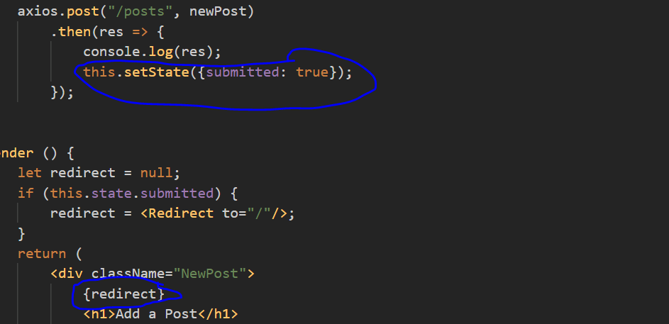

* 1. Using the History Prop to Redirect (Replace)
     1. If we redirect from history push() then it will add new route so if we click back button then it will show the last page.

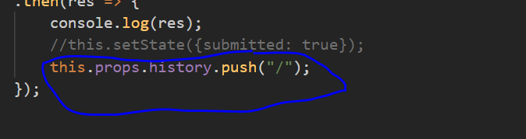

* + 1. If we want to replace page then we can use replace()

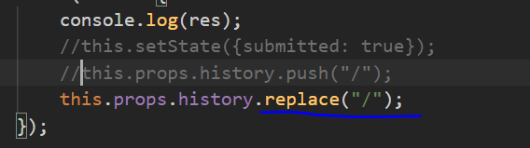

* 1. Working with Guards

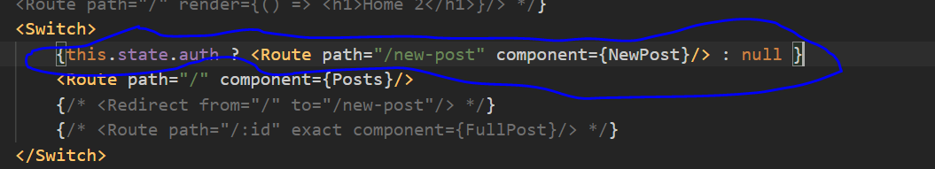

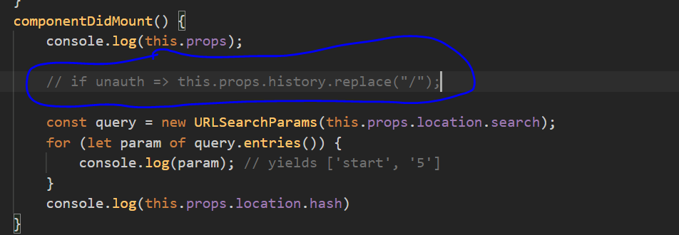

* 1. Handling the 404 Case (Unknown Routes)
     1. It won’t work with redirect



* 1. Loading Routes Lazily
     1. We can do lazy loading using HOC and import component when it needed.

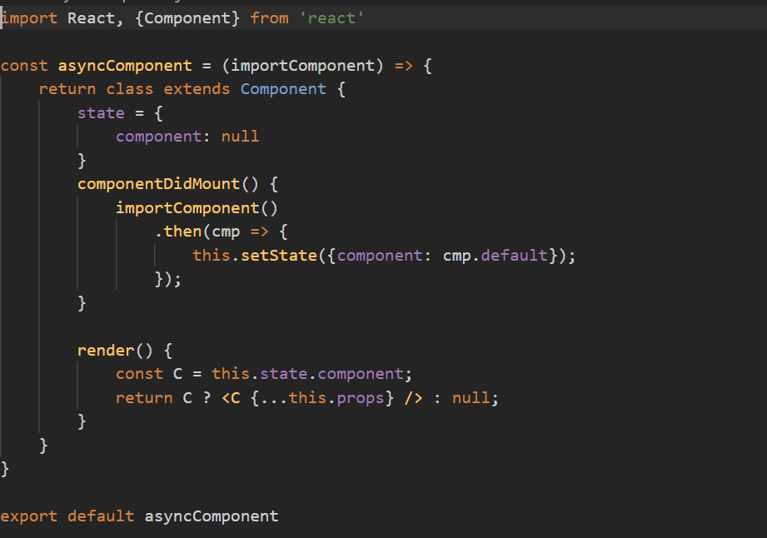

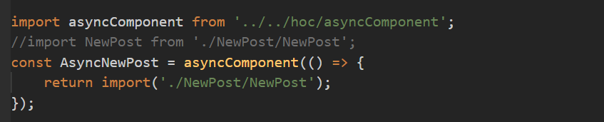

* 1. Lazy Loading with React Suspense (16.6 and latest)
     1. Here we use React.lazy() and <Suspense fallback></Suspense>

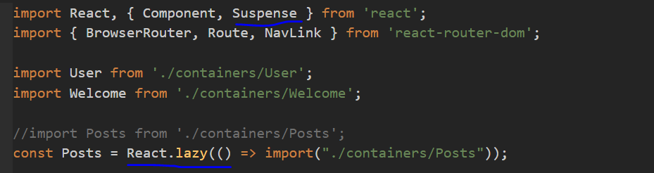

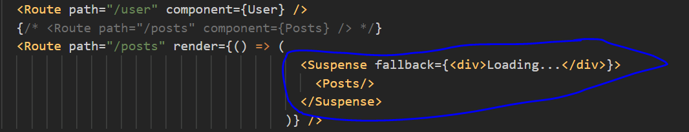

* + 1. Render based on condition

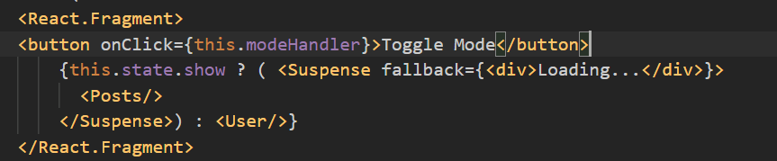

* 1. Routing and Server Deployment
     1. We can set base name(default value: “/”)

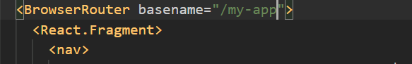

1. Forms and Form Validation
2. Redux
   1. It is a library often used in react projects though to make state management.

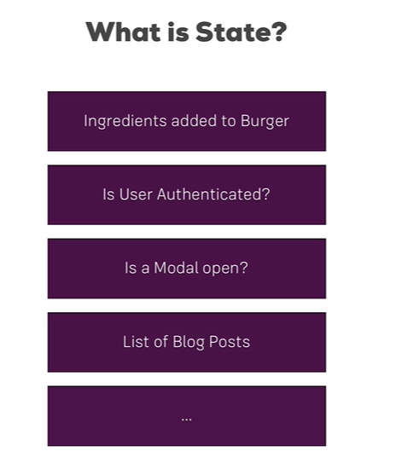

* 1. Redux Flow

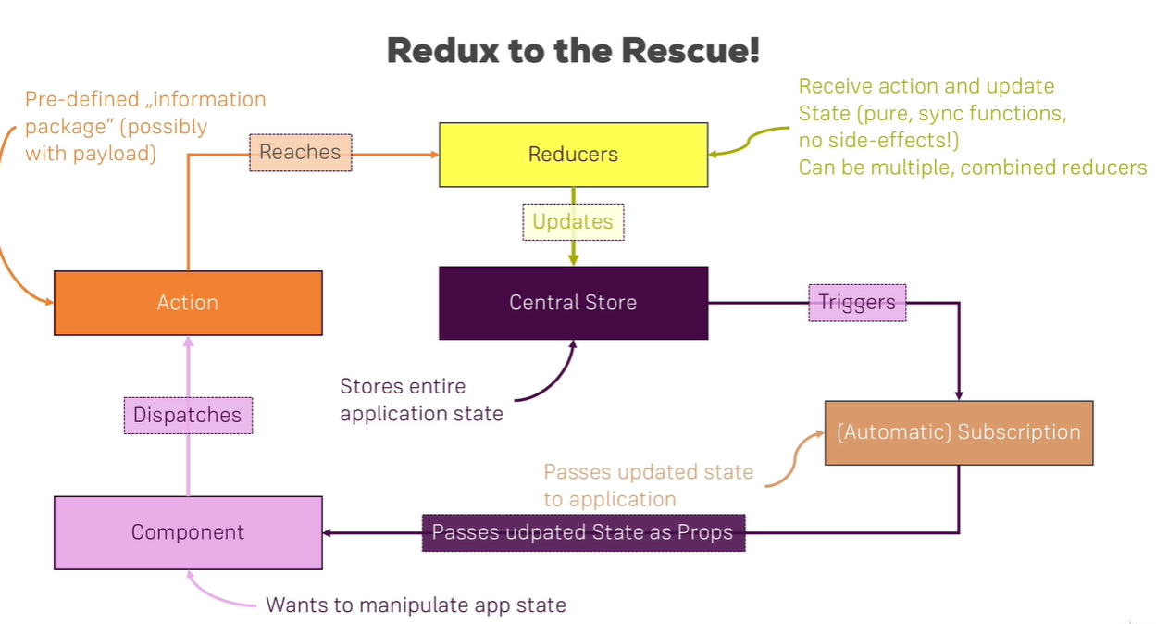

* 1. Setting Up Reducer and Store
     1. Redux is independent from react
     2. npm i –save redux

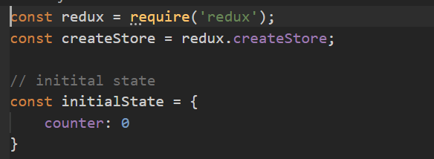

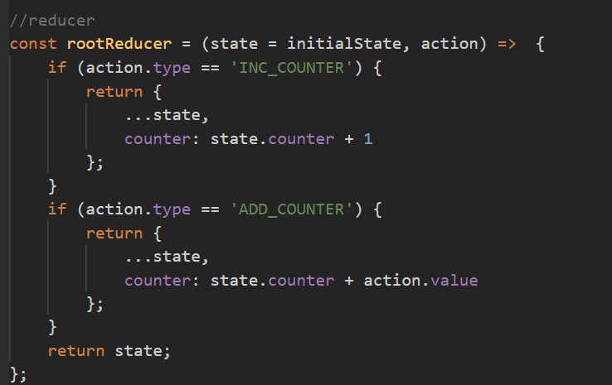

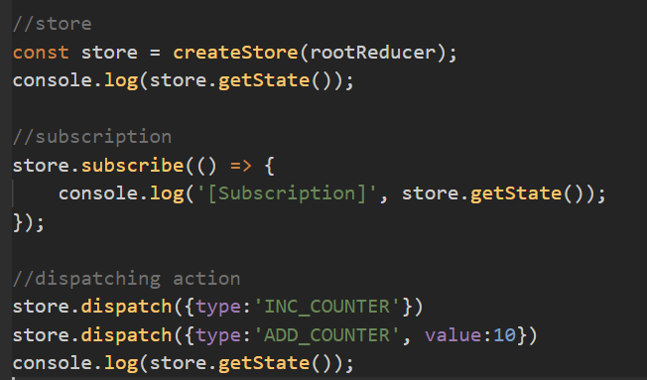

* 1. Connecting React to Redux
     1. npm i –save react-redux
     2. use Provider to link redux into react app

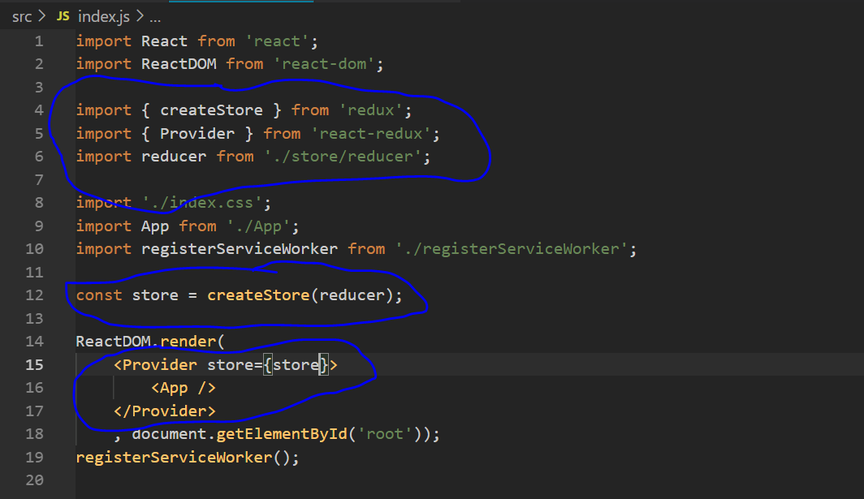

* 1. use connect in Component

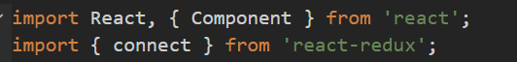

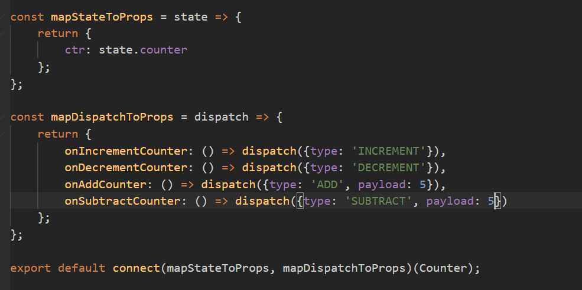

* 1. common reducer

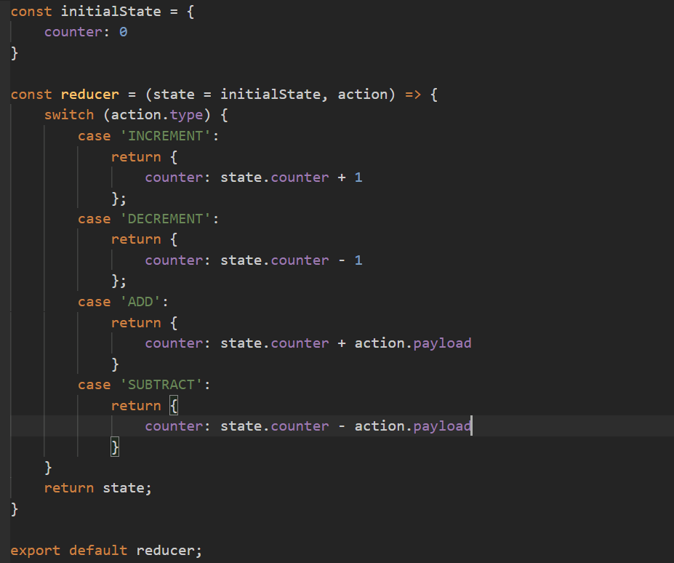

* 1. action types

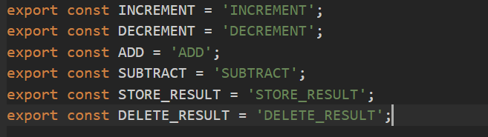

* 1. combining multiple reducers

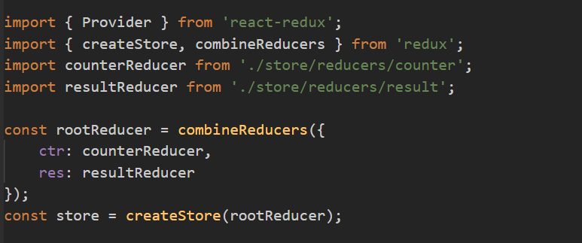

* 1. types of state

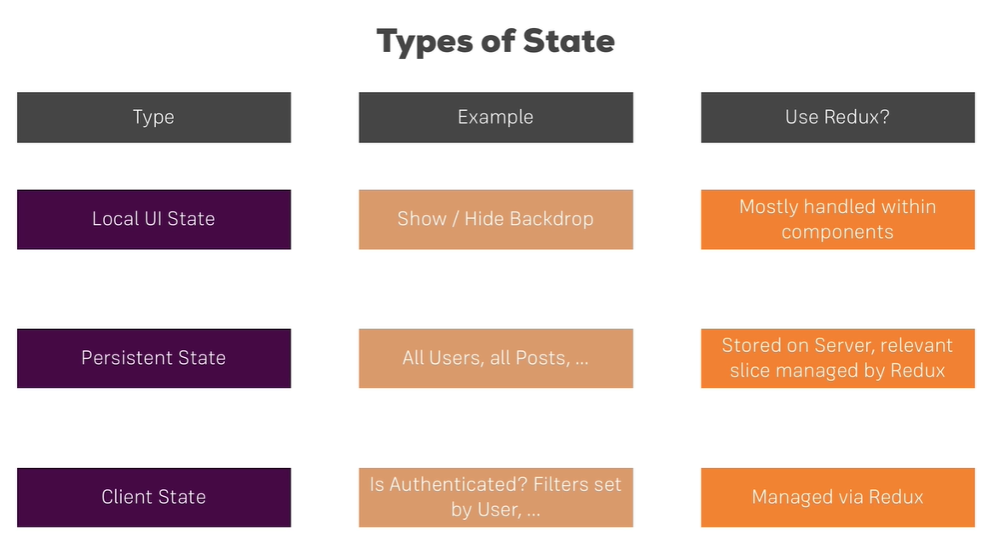

1. Advanced redux
   1. Middleware
      1. Use to add some login between action dispatch and it reaches to reducer.

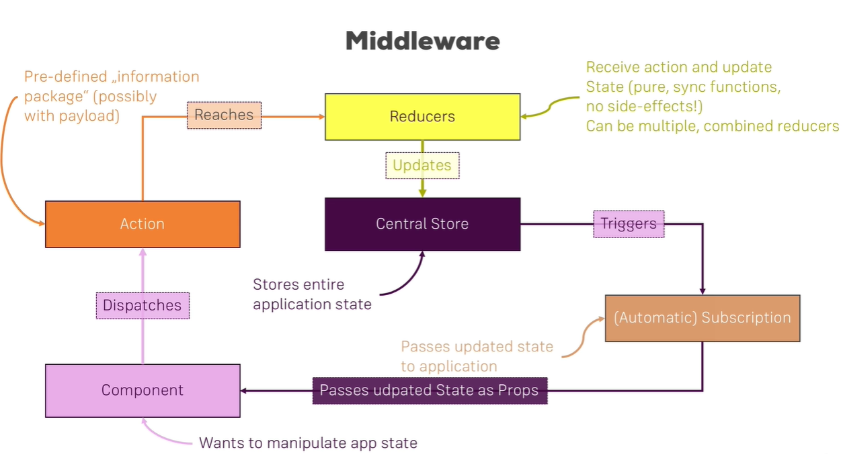

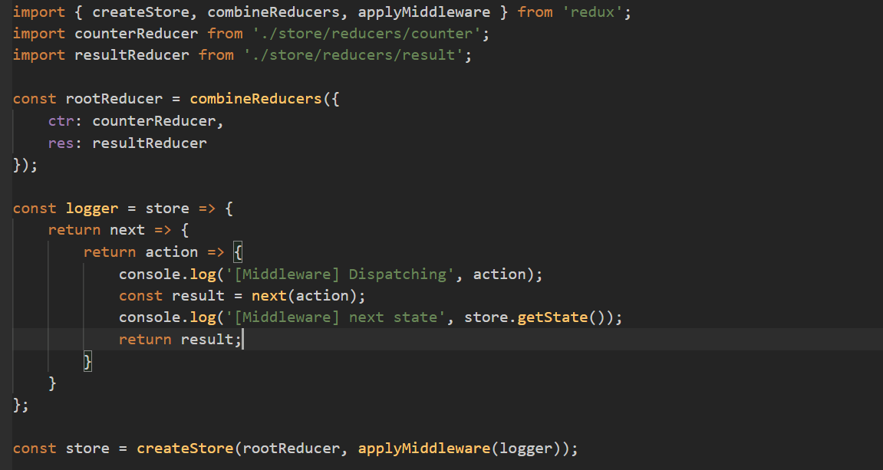

* 1. Using the Redux Devtools
     1. With middleware

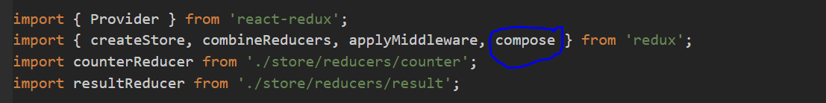

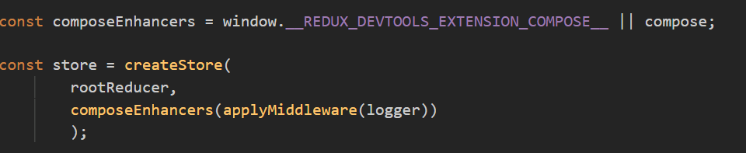

* + 1. Without middleware

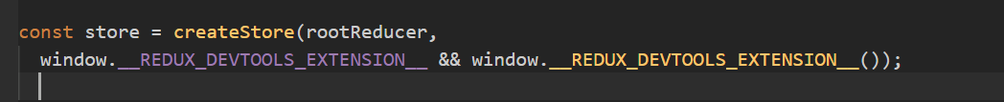

* 1. Introducing Action Creators

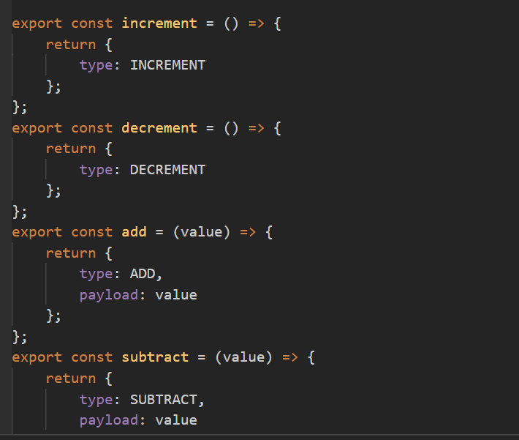

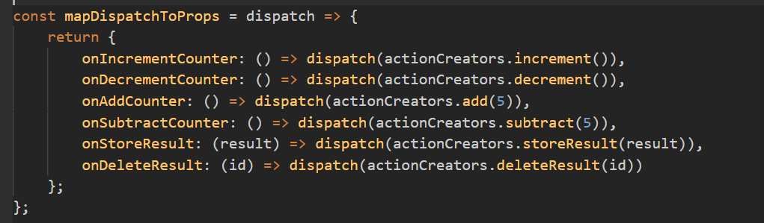

* 1. Handling Asynchronous Code
     1. npm install --save redux-thunk
     2. use to call api and store data in redux store

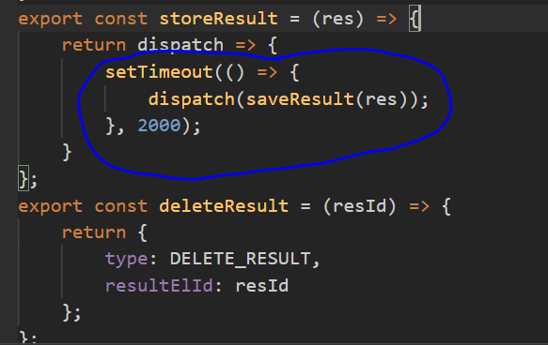

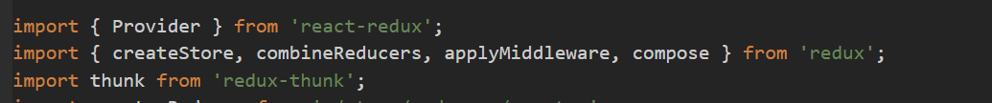

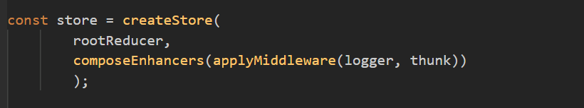

* 1. Where to Put Data Transforming Logic

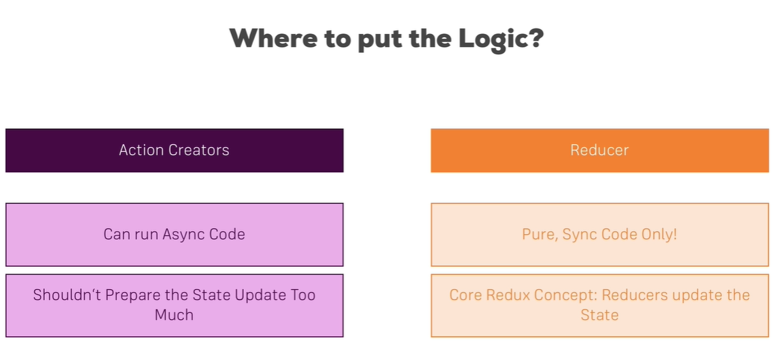

* 1. Using Action Creators and Get State

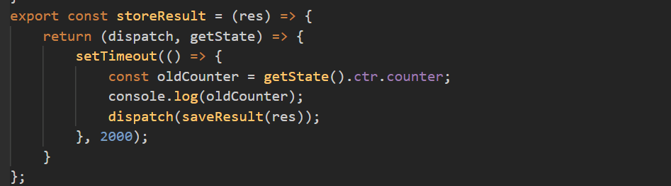

* 1. Utility Function

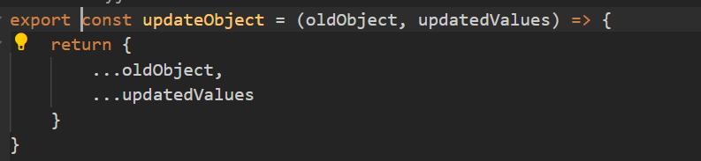

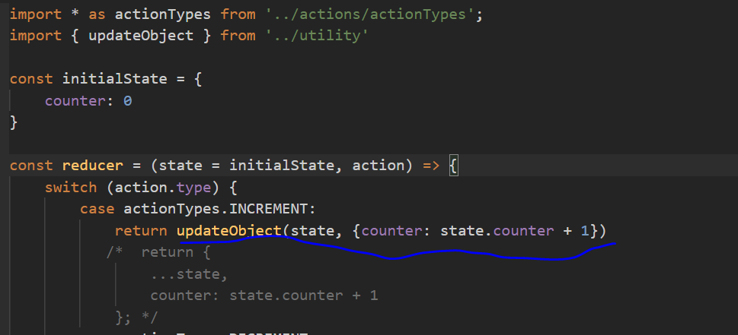

* 1. Leaner switch case statement

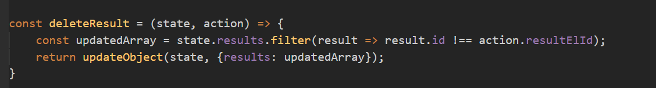



* 1. immutable-update-patterns

<https://redux.js.org/recipes/structuring-reducers/immutable-update-patterns>

1. Authentication in SPA
   1. Understanding Authentication in Single Page Applications

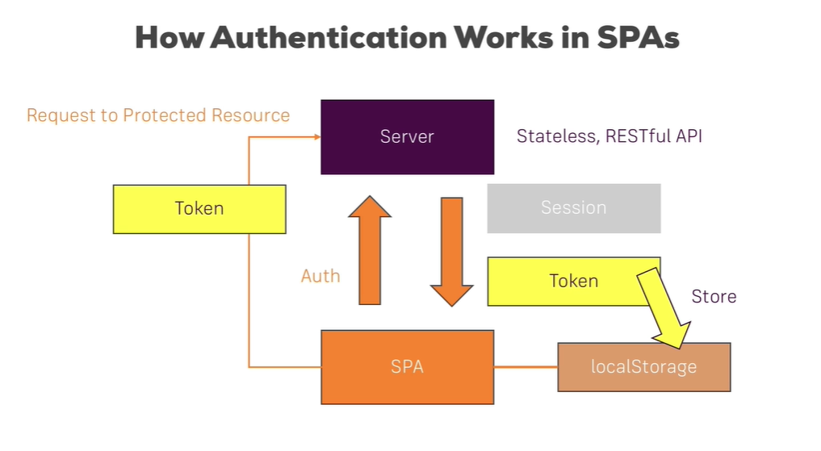

1. Some other functionality
   1. Use Shared code in whole app by creating utility.js file add all common function there.



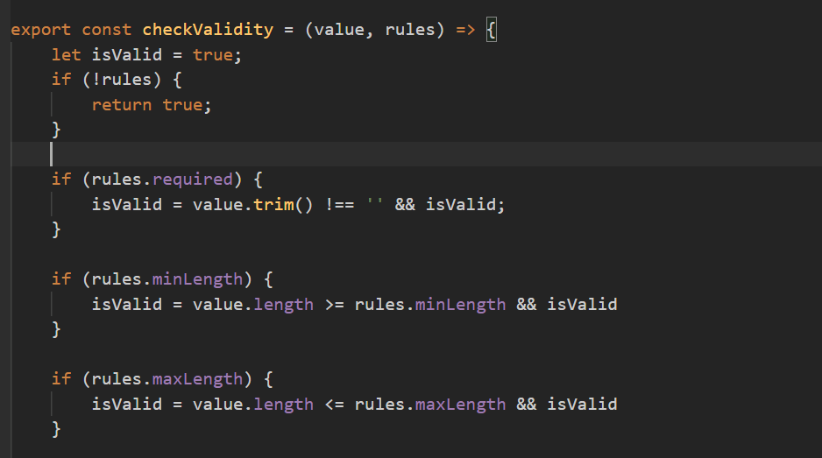

* 1. Using Environment Variables
     1. To disable redux dev tools in production.

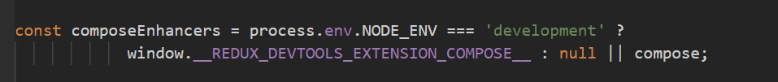

1. Testing
   1. Introduction

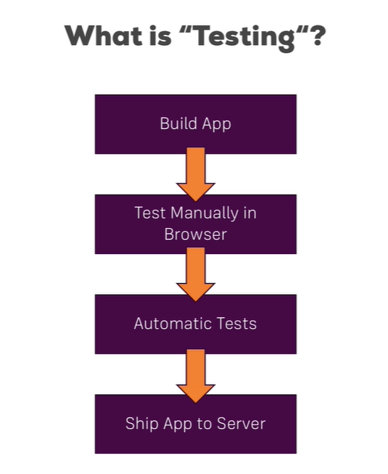

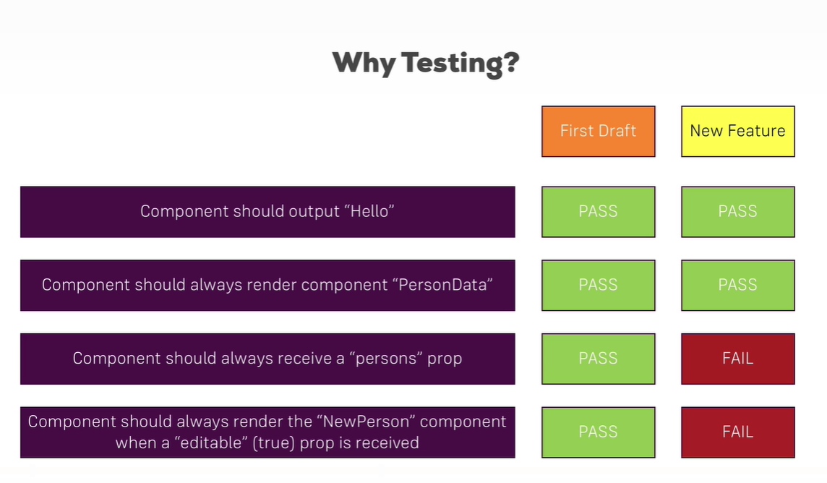

* 1. Testing Tools
     1. Jest – it is a test runner which allow us to executes tests and provide validation library.
     2. Enzyme- It is a testing utilities which allow us to simulates the React apps (mounts component, allow to dig into the DOM)

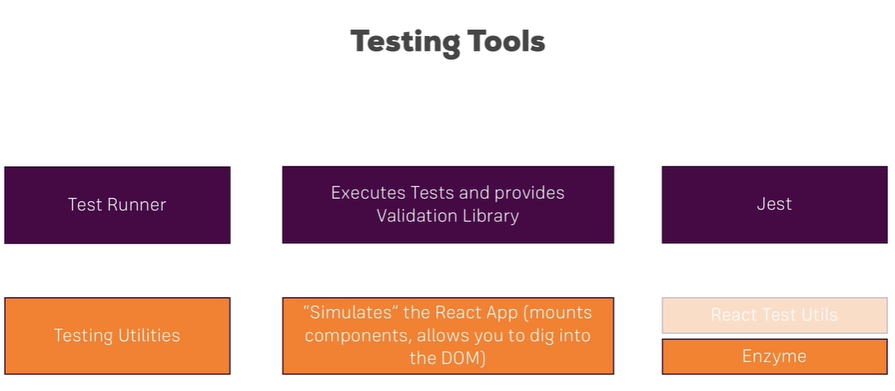

* 1. What to tests
     1. Isolated unit means: reducer functions

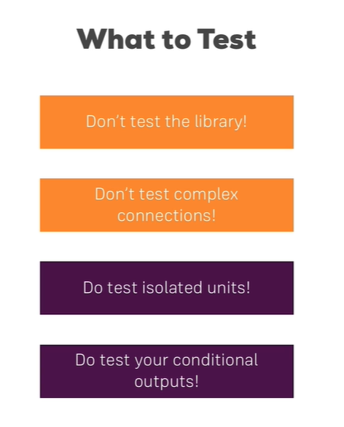

* 1. Install packages
     1. Jest is available by default with react app
     2. Enzyme we need to install for testing

npm install –save enzyme react-test-renderer enzyme-adpater-react-16

* 1. Write test case for Components
     1. Create file with *.test.js

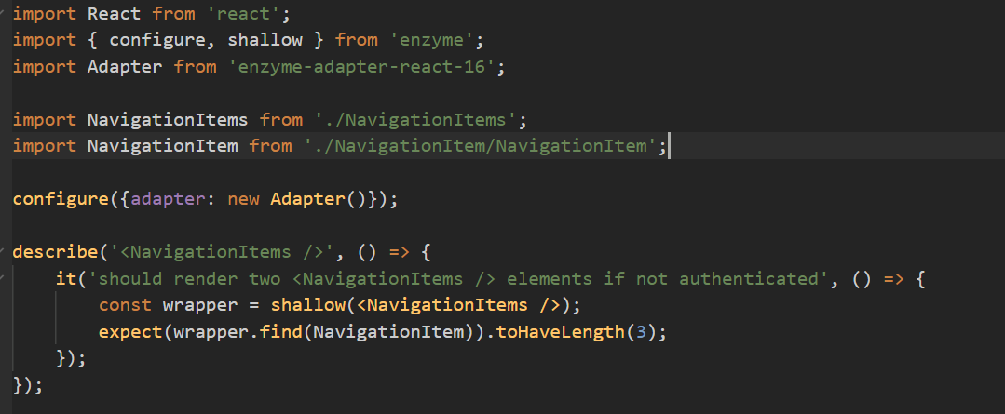

* + 1. Run test files command: npm run test or npm test
    2. Multiple test case in single file

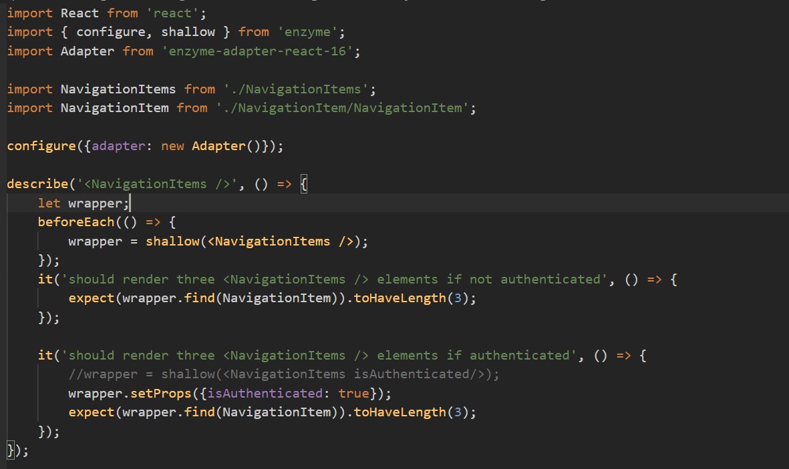

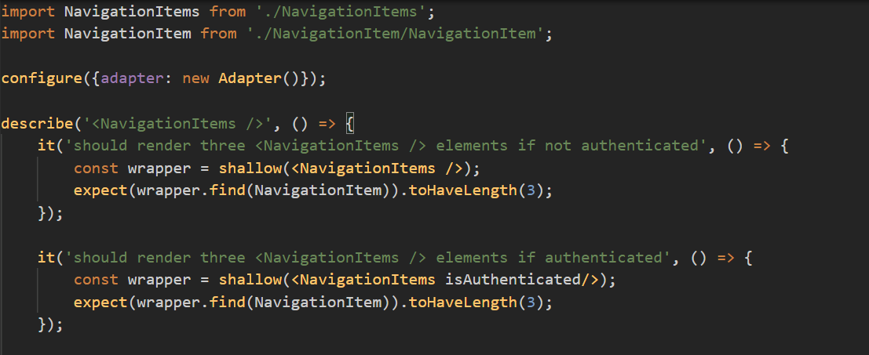

* 1. Documentation link
     1. <https://jestjs.io/docs/api>
     2. <https://enzymejs.github.io/enzyme/>
  2. Testing containers
     1. May get error so add export in class

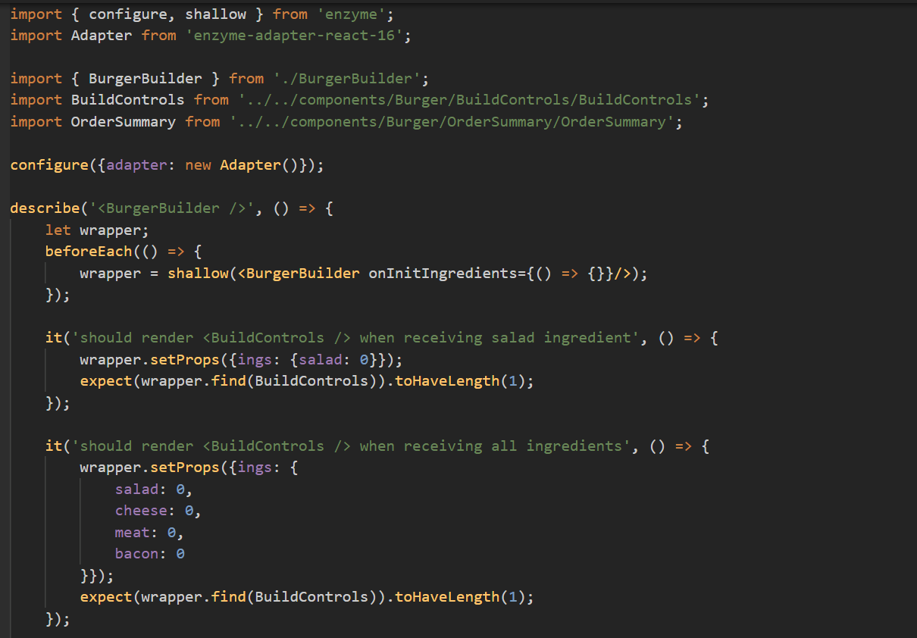

* 1. Test to Redux reducer

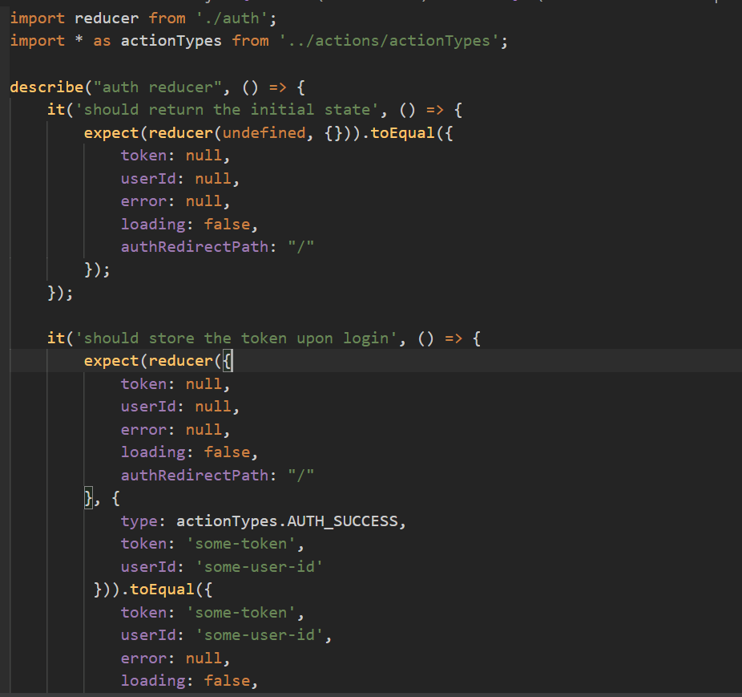

1. Deployment

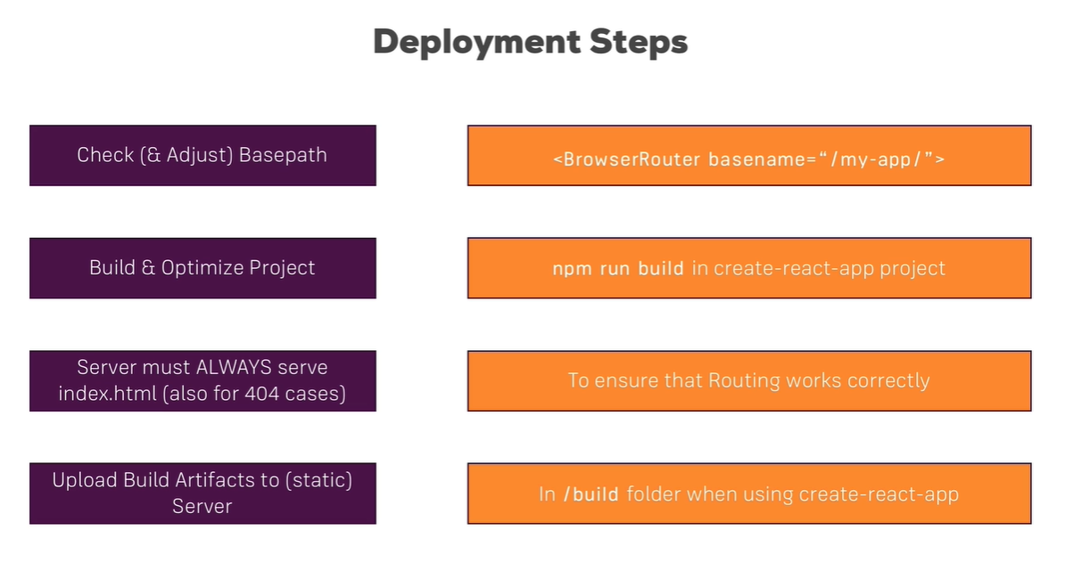

* + 1. Set Base path in <BrowserRouter basename=”/my-app/” ><BrowserRouter>
    2. Command to build : npm run build
    3. Deploy to firebase
       1. npm install -g firebase-tools
       2. firebase login
       3. firebase init
       4. firebase deploy

1. Webpack
   1. It allow us to optimize files and create bundles and also allow us to use loaders and also transpile next Gen java script to default java script.

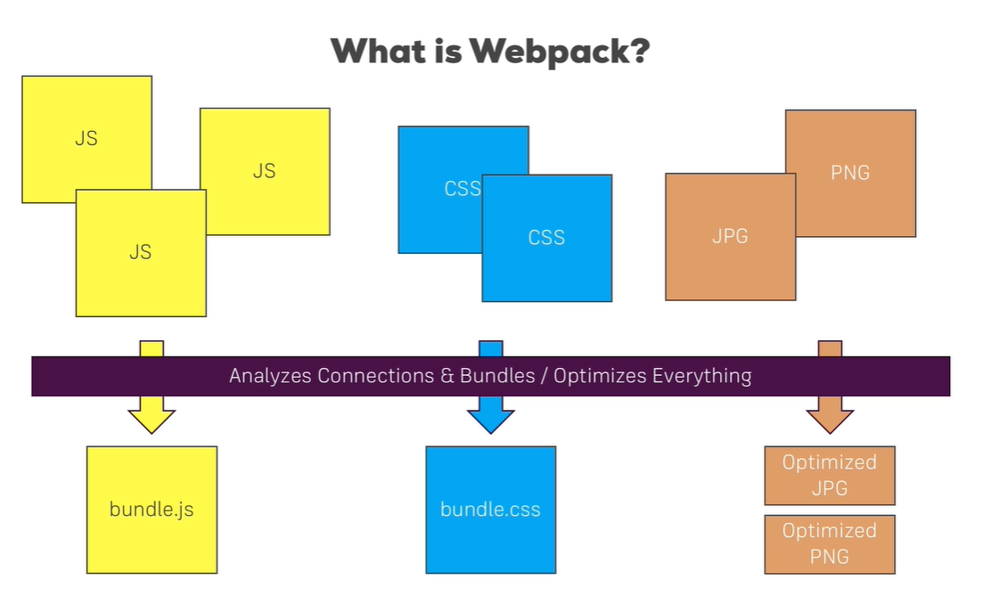

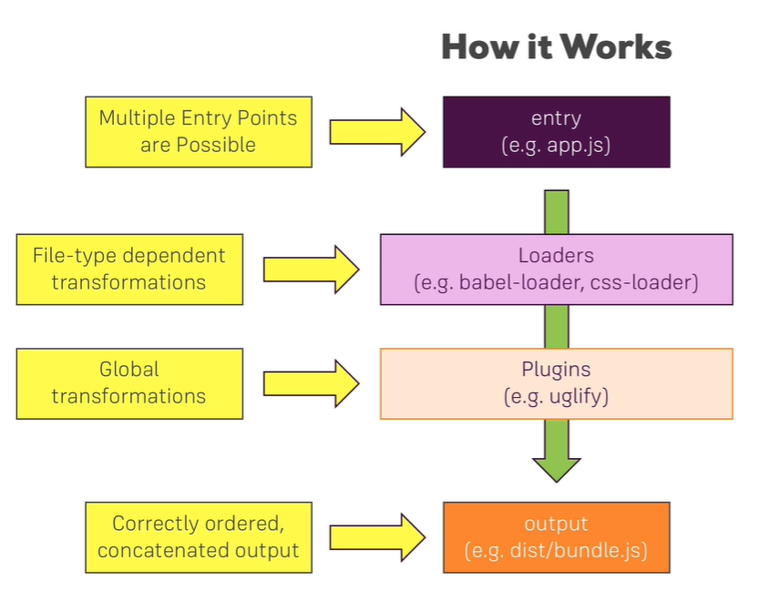

* 1. Basic workflow requirement

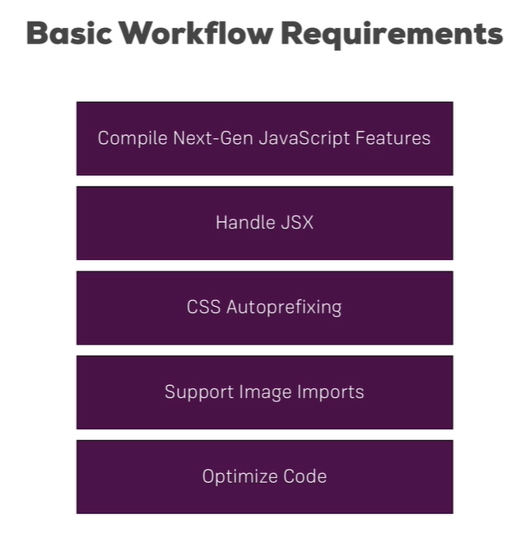

* 1. Command:
     1. Step 1: npm init
     2. Step 2: npm install **–save-dev webpack** **webpack-dev-server**
     3. Step 3: write all code in files like index.js, app.js, index.html
     4. Step 4: npm install **–save** **react** **react-dom** **react-router-dom**
     5. Step 5: npm install –save-dev webpack-cli
     6. Step 6: write code in package.json

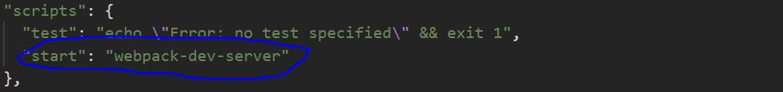

* + 1. Step 7: add webpack.config.js file in root folder

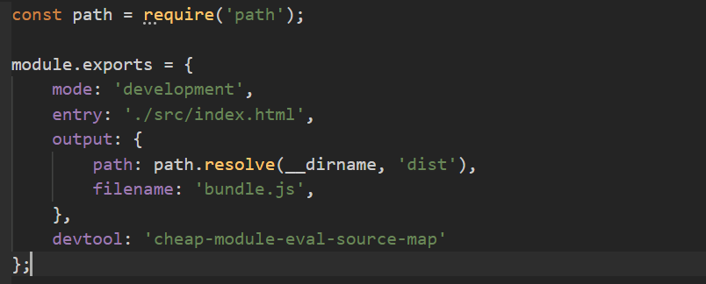

* + 1. Step 8: add other dependency - npm install --save-dev @babel/core @babel/preset-env @babel/preset-react @babel/preset-stage-2 babel-loader @babel/plugin-proposal-class-properties (babel used to convert next gen java script code to browser support java script code)
    2. Step 9: add extra code in webpack.config.js

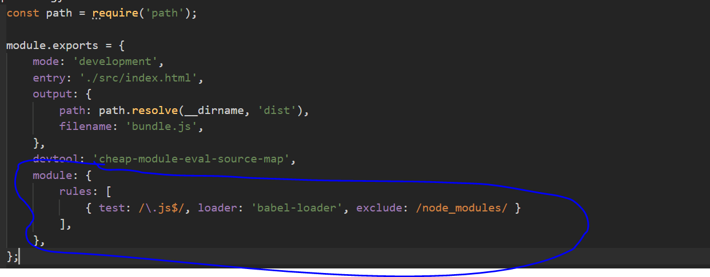

* + 1. Step 10: create new file at root level **.babelrc**

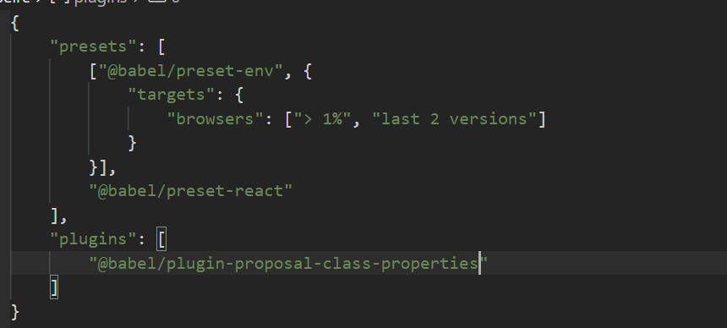

* + 1. Step 11: npm install –save-dev style-loader css-loader

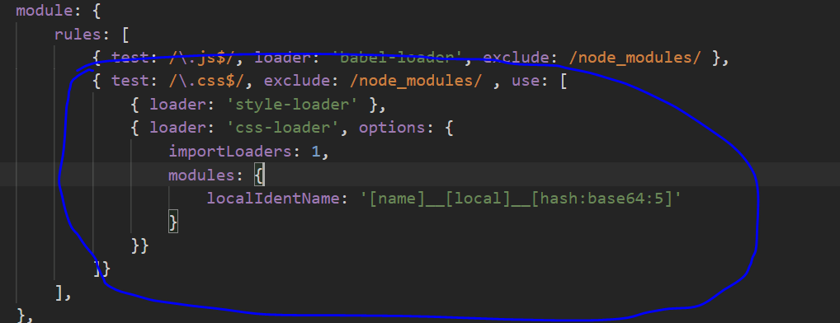

* + 1. Step 12: npm install –save-dev postcss-loader
    2. Step 13: add code in webpack.config.js

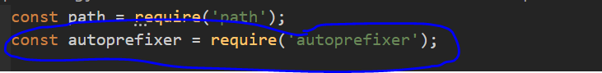

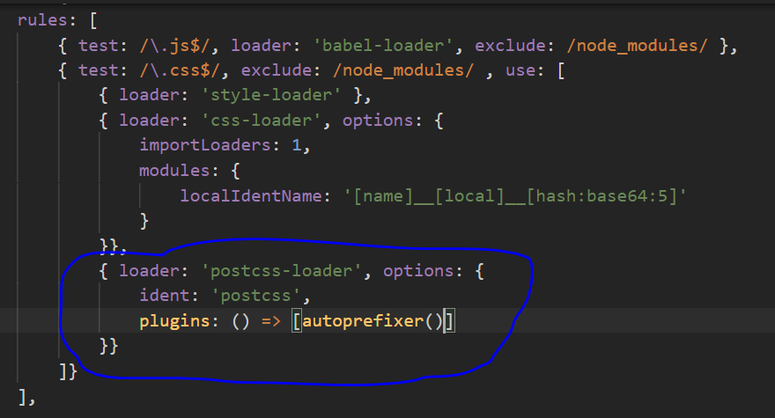

* + 1. Step 14: Add code in package.json

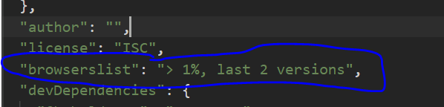

* + 1. Step 15: npm install –save-dev url-loader

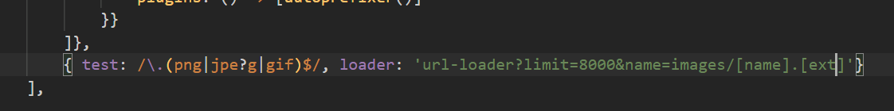

* + 1. Step 16: npm install –save-dev html-webpack-plugin

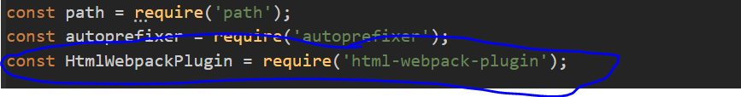

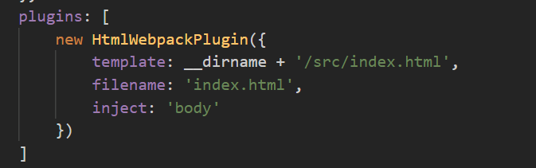

* + 1. Step 17: npm install –save-dev file-loader

1. Animations
   1. Default CSS animation

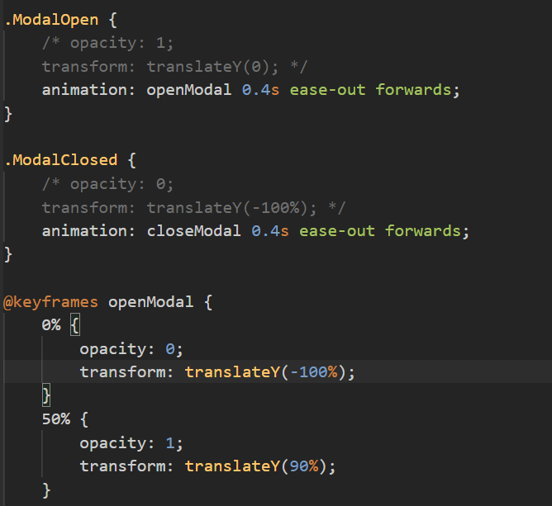

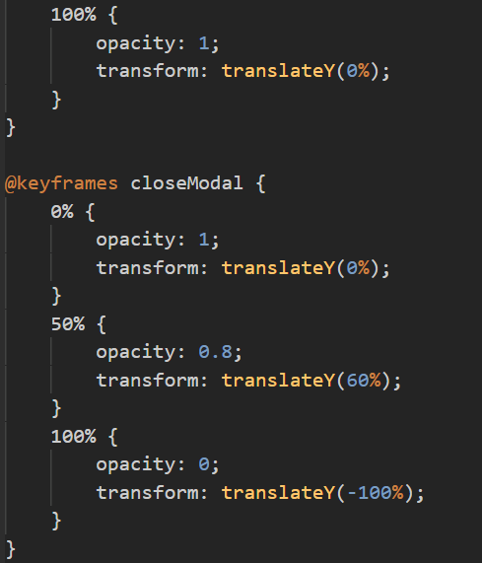

* 1. React transition group
     1. <https://reactcommunity.org/react-transition-group/>
     2. Transition : The Transition component lets you describe a transition from one component state to another over time with a simple declarative API.

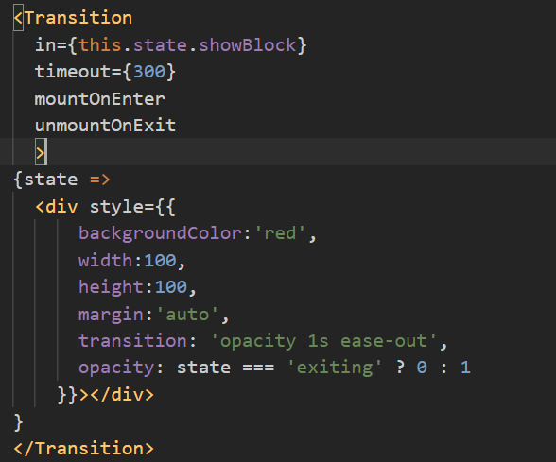

* 1. Animation Timings

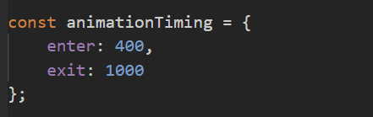

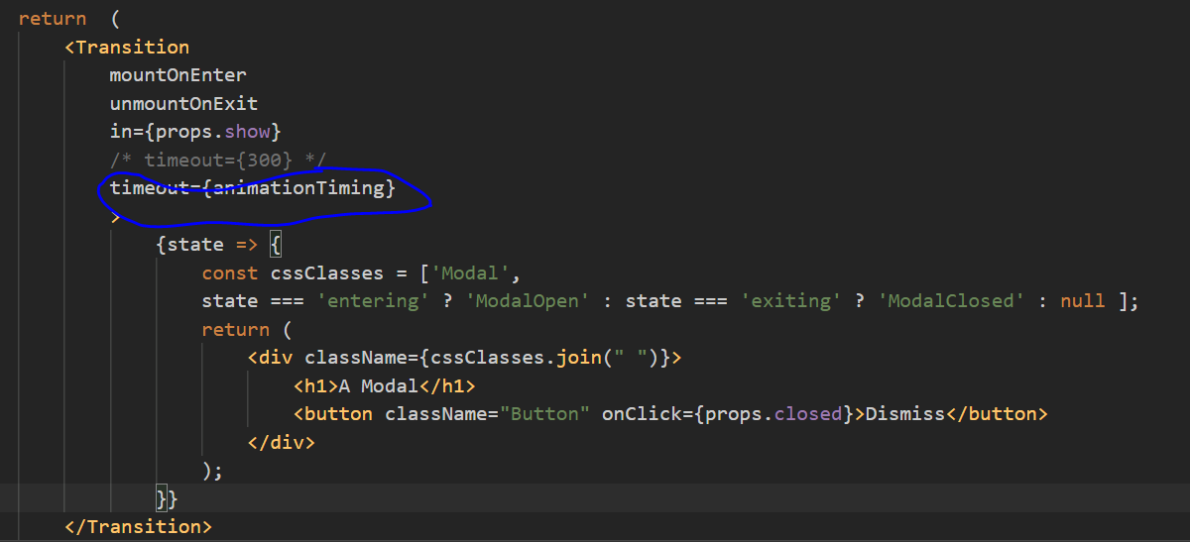

* 1. Transition Events

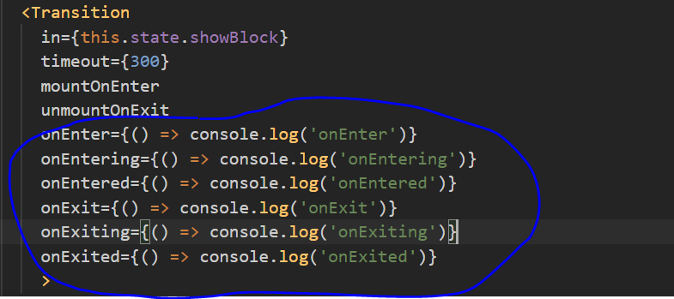

* 1. CSSTransition Component

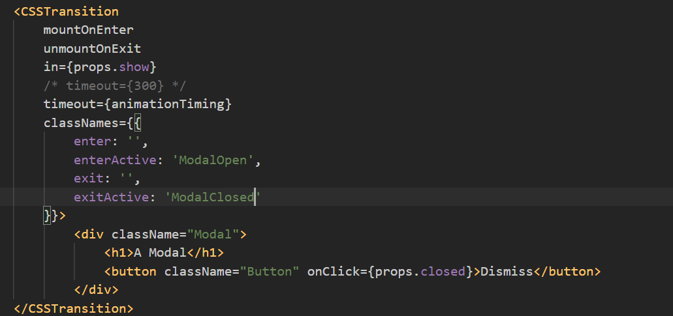

* 1. Animating List

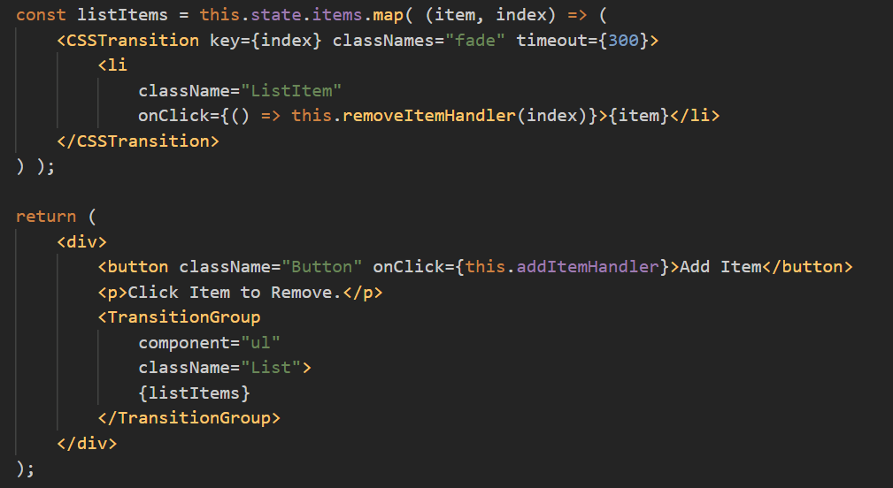

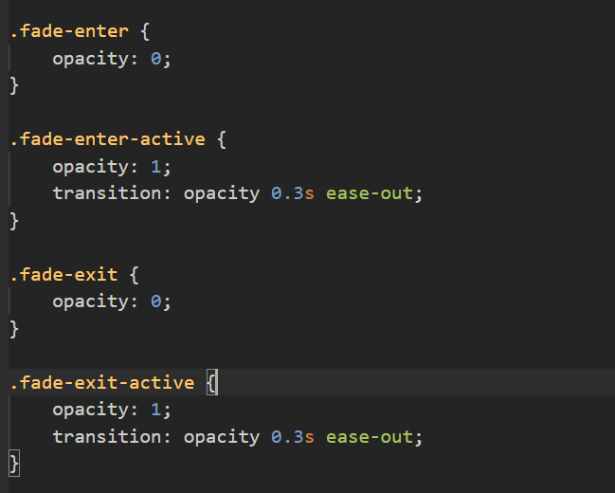

* 1. Alternative Animation Packages
     1. React motion library
     2. React Move
     3. React Router Transition

1. Redux Saga
   1. An alternative to redux-thunk
   2. npm install –save redux-saga
   3. https://redux-saga.js.org/
2. React Hooks
   1. Hooks allow you to add state to functional component and also life cycle method and share logic across components.
   2. Introduced with React 16.8
   3. React useState()
      1. Class based state always store object but useState can store object or array or Boolean or any type.
      2. Class based setState() just merge the object only which we pass in function (update single field), but in hooks useState() setState() just replace the whole data with what we pass in function(update whole object).

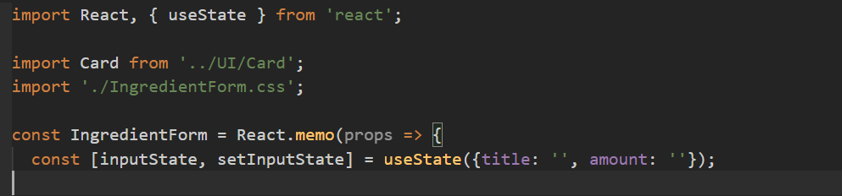

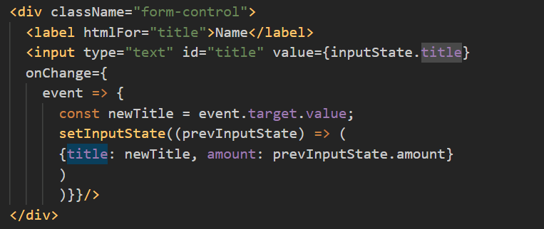

* 1. Multiple State

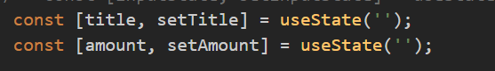

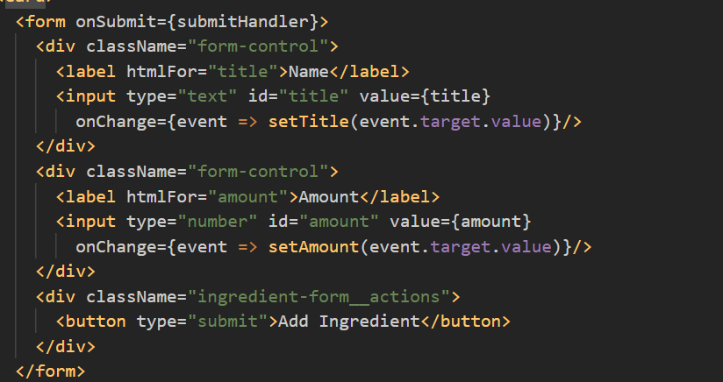

* 1. React useEffect()
     1. useEffect is like componentDidUpdate(), it run the function on after every component update (re-render)

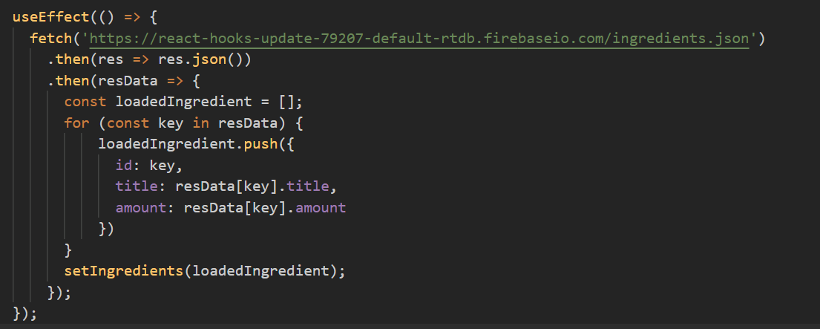

* + 1. If we pass [] as second argument in useEffect() then it run only once like componentDidMount().

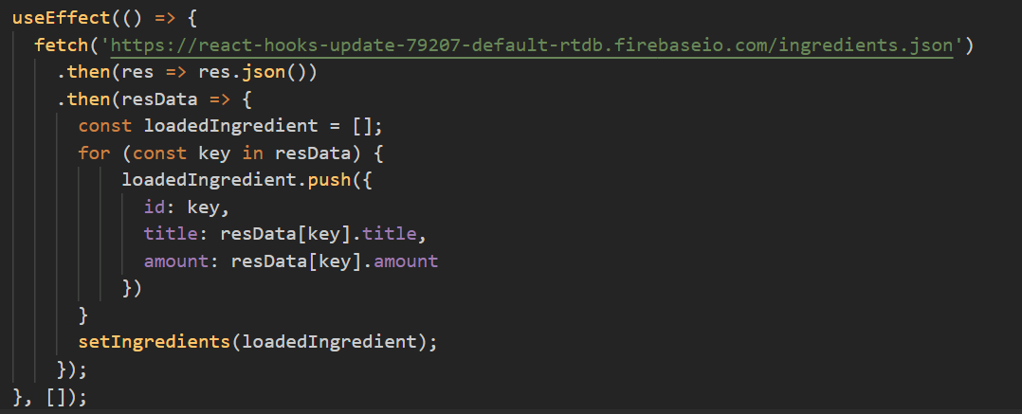

* + 1. Control useEffect call based on any object or state

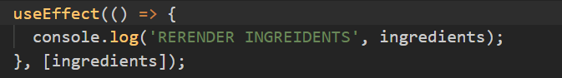

* 1. React useCallback()
     1. It is use to control function execution

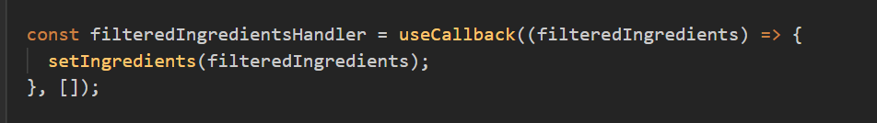

* 1. Working with Refs & useRef()
     1. Using ref we can get current value of input inside timeout.

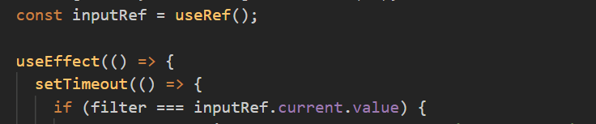

* 1. Cleaning Up with useEffect()
     1. Behave as componentDidUnmount
     2. It runs before useEffect run next time.

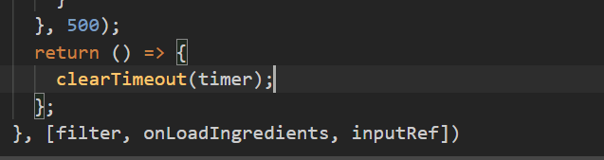

* 1. State Update Batching(Multiple setState call) and when new state is available
     1. All state updates from one and the same synchronous event handler are batched together

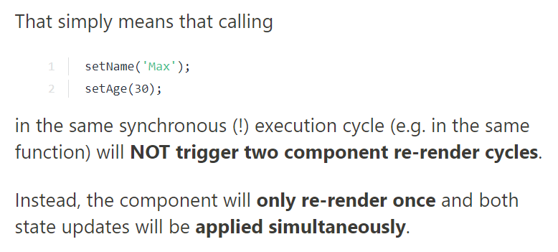

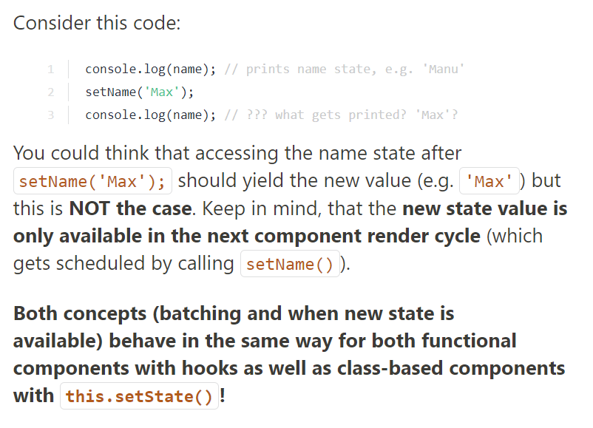

* 1. React useReducer()
     1. It has absolutely no connection to the redux library
     2. When working with useReducer(), React will re-render the component whenever your reducer returns the new state.

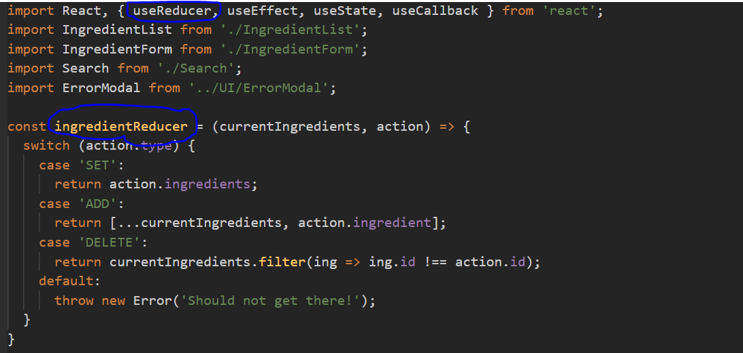



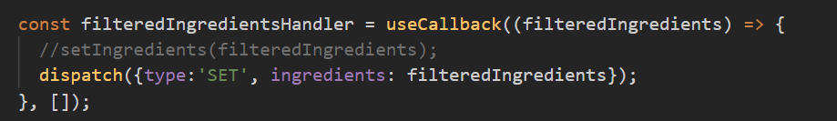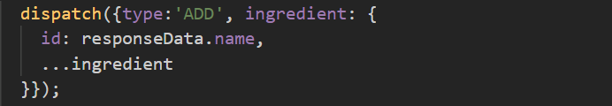

* 1. Working with useContext()

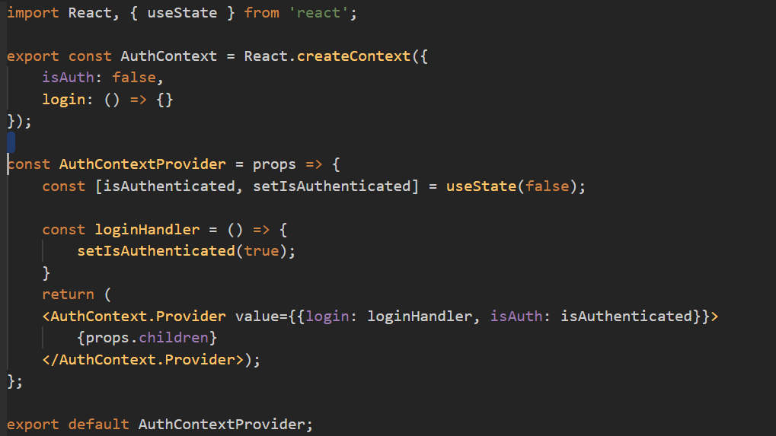

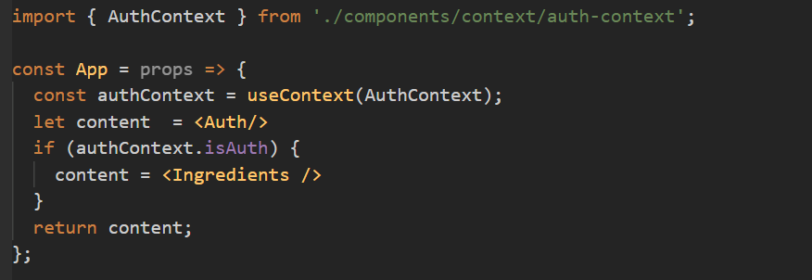

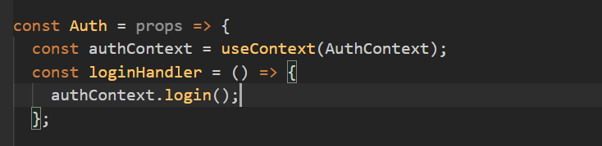

* 1. Performance Optimizations with useMemo()
     1. useMemo is use to render any component inside a component based on state change.



* 1. Getting Started with Custom Hooks
  2. Add condition in React.memo() (can be use in place of shouldComponentUpdate)

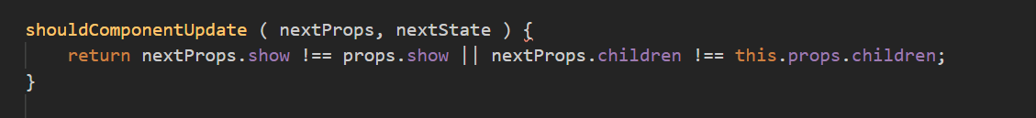



* 1. Custom Error Handling Hook

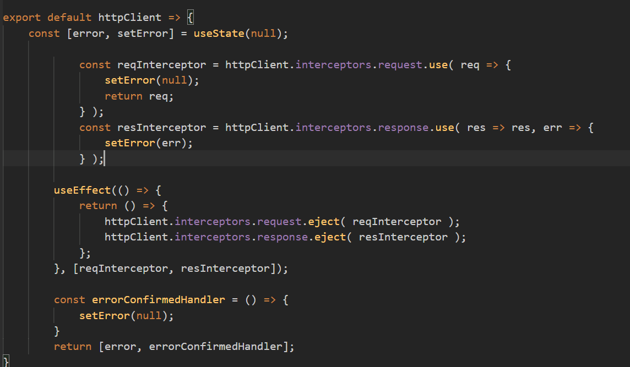

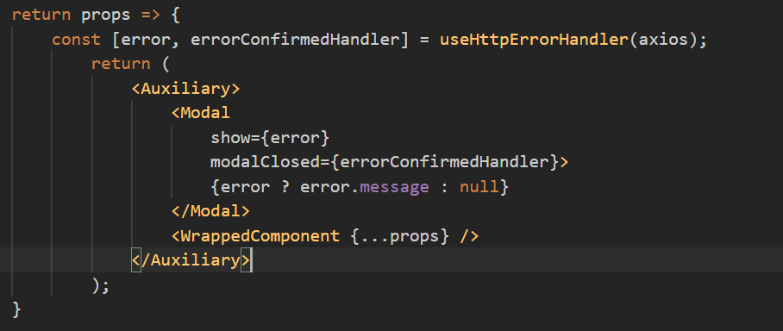

* 1. Setting the right useEffect() Dependencies

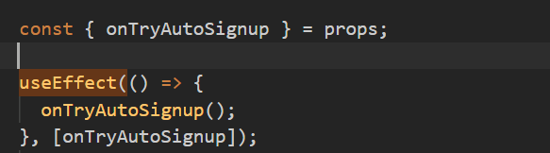

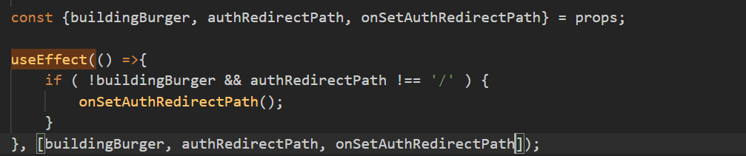

* 1. Working with useSelector() and useDispatch()

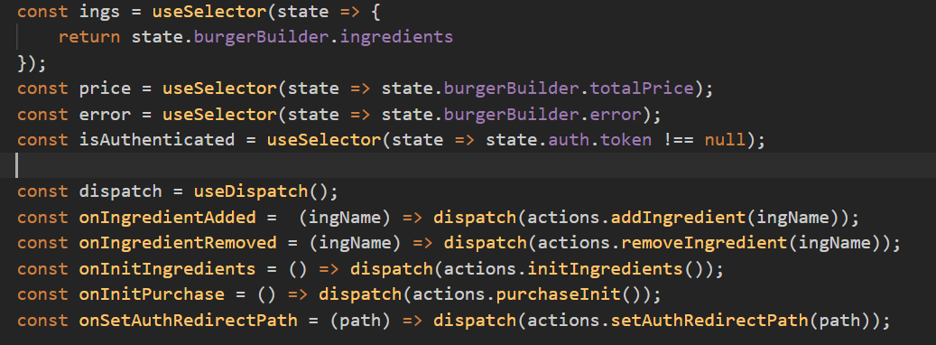

* 1. List of hooks
     1. [Basic Hooks](https://reactjs.org/docs/hooks-reference.html#basic-hooks)
        1. [useState](https://reactjs.org/docs/hooks-reference.html#usestate)
        2. [useEffect](https://reactjs.org/docs/hooks-reference.html#useeffect)
        3. [useContext](https://reactjs.org/docs/hooks-reference.html#usecontext)
     2. [Additional Hooks](https://reactjs.org/docs/hooks-reference.html#additional-hooks)
        1. [useReducer](https://reactjs.org/docs/hooks-reference.html#usereducer)
        2. [useCallback](https://reactjs.org/docs/hooks-reference.html#usecallback)
        3. [useMemo](https://reactjs.org/docs/hooks-reference.html#usememo)
        4. [useRef](https://reactjs.org/docs/hooks-reference.html#useref)
        5. [useImperativeHandle](https://reactjs.org/docs/hooks-reference.html#useimperativehandle)
        6. [useLayoutEffect](https://reactjs.org/docs/hooks-reference.html#uselayouteffect)
        7. [useDebugValue](https://reactjs.org/docs/hooks-reference.html#usedebugvalue)
     3. Router
        1. useHistory
     4. Redux
        1. useDispatch
        2. useSelector

1. Course Round Up
   1. React Rocks! Where to find more Examples
      1. <https://react.rocks/>
   2. Gatsby Js
      1. <https://www.gatsbyjs.com/>
      2. Help us to create static site using react
   3. React Native
      1. Create native apps for Android and iOS using React
   4. Component Libraries (Example: Material UI)
      1. <https://material-ui.com/>
   5. Preact
      1. Fast 3kB alternative to React with the same modern API
      2. <https://preactjs.com/>